**B. Tech. project Grace Marks Allocator– G 22**

**PROJECT REPORT-I**

***Submitted by***

|  |  |  |
| --- | --- | --- |
| **S. No** | **Name** | **Roll Number** |
| 1. | G Lokesh | CB.EN.U4CSE18117 |
| 2. | P Pruthve Rej | CB.EN.U4CSE18136 |
| 3. | N Pavan Kruthik | CB.EN.U4CSE18137 |
| 4. | P Upendra | CB.EN.U4CSE18138 |
| 5. | Sk Awez | CB.EN.U4CSE18148 |

***is fulfilment of the requirements for the Course – 15CSE376 (Net Centric Programming)***

**BACHELOR OF TECHNOLOGY IN**

**COMPUTER SCIENCE AND ENGINEERING**



**DEPARTMENT OF COMPUTER SCIENCE AND ENGINEERING**

**AMRITA SCHOOL OF ENGINEERING**

**AMRITA VISHWA VIDYAPEETHAM**

**COIMBATORE -641112**

**August 2021**

**Table of Contents**

|  |  |  |
| --- | --- | --- |
| **S.No** | **Section Name** | **Page Number** |
| 1 | Abstract | 3 |
| 2 | Introduction to web designing | 4 |
| 3 | Design Diagram | 6 |
| 4 | Implementation | 7 |
| 5 | Evaluation sheet | 25 |

**Abstract**

* Every year the tracking of paper publications that provide students with grace marks and finding the right subject to which the marks can be added in order to increase the grade of the student in the best way possible is a very manually hectic job
* We have designed a software that eases the tedious process of handling the allocation of Grace marks to students belonging to a semester, impartially
* To do so, we set rules that govern the generation of grace marks and constrain them. Grace marks are generated on the basis of the proofs that have been submitted and verified
* The generated marks are then added to the existing marks and published.

**Introduction to web designing:**

**What is HTML?**

HTML is the language for describing the structure of Web pages. HTML gives authors the means to:  
● Publish online documents with headings, text, tables, lists, photos, etc.  
● Retrieve online information via hypertext links, at the click of a button.  
● Design forms for conducting transactions with remote services, for use in searching for information, making reservations, ordering products, etc.  
● Include spread-sheets, video clips, sound clips, and other applications directly in their  
documents

With HTML, authors describe the structure of pages using markup. The elements of the  
language label pieces of content such as “paragraph,” “list,” “table,” and so on

**CSS:**

Cascading Style Sheets (CSS) is a stylesheet language used to describe the presentation of a document written in HTML or XML. CSS describes how elements should be rendered on screen, on paper, in speech, or on other media. CSS is used to style and layout web pages — for example, to alter the font, colour, size, and spacing of your content, split it into multiple columns, or add animations and other decorative features. This module provides a gentle beginning to your path towards CSS mastery with the basics of how it works, what the syntax looks like, and how you can start using it to add styling to HTML.

**JavaScript:**

JavaScript (JS) is a lightweight, interpreted, or just-in-time compiled programming language with first-class functions. While it is most well-known as the scripting language for Web pages, many non-browser environments also use it, such as Node.js, Apache CouchDB and Adobe Acrobat. JavaScript is a prototype-based, multi-paradigm, single-threaded, dynamic language, supporting object-oriented, imperative, and declarative styles.

**Embedded JavaScript:**

You can embed JavaScript in an HTML document in the following ways: As statements and functions within a <SCRIPT> tag. ... See "Specifying a file of JavaScript code". By specifying a JavaScript expression as the value for an HTML attribute. See "Using JavaScript expressions as HTML attribute values".

 

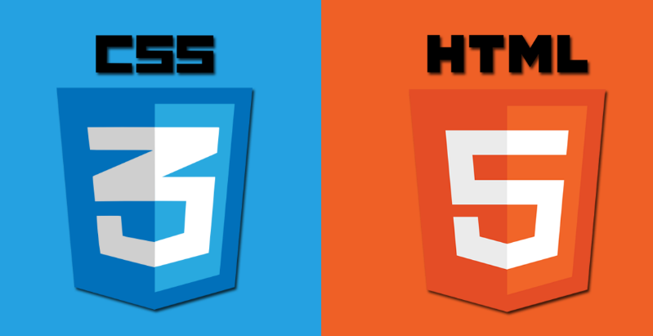

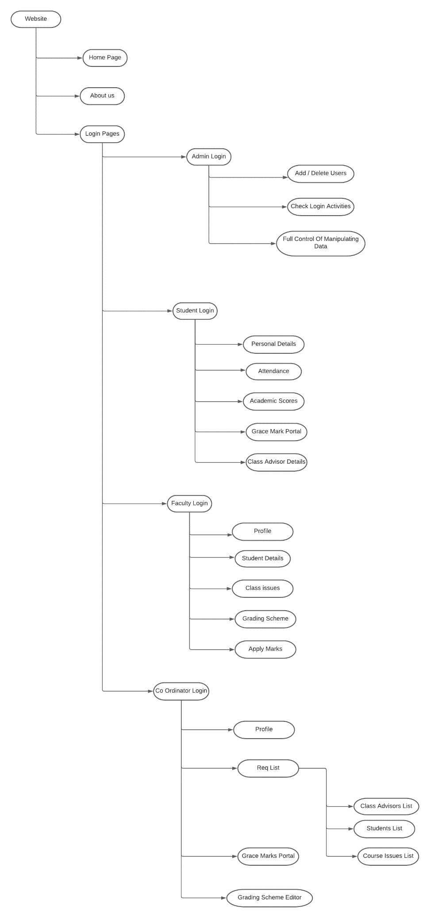**Design diagram:**

**Implementation:**

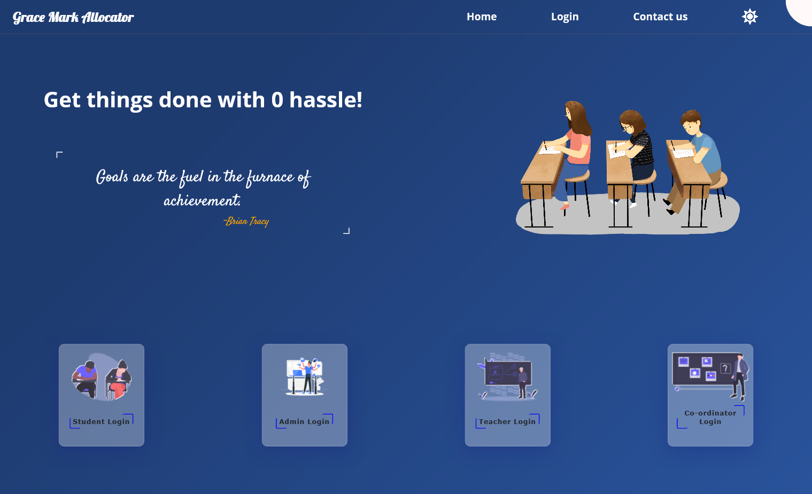

**Description:**

This page is the landing page of our website where users can choose their respective login page.

**Code snippet:**

<!DOCTYPE html>

<html lang="en">

  <head>

    <meta charset="UTF-8" />

    <meta http-equiv="X-UA-Compatible" content="IE=edge" />

    <meta name="viewport" content="width=device-width, initial-scale=1.0" />

    <title>Document</title>

    <link rel="stylesheet" href="http://localhost:5000/css/home.css" />

  </head>

  <form method="GET", action="http://localhost:8000/">

  <body>

    <div class="header">

      <h2 class="head">Grace Mark Allocator</h2>

      <div class="login">

        <a href="">Home</a>

        <a href="#box">Login</a>

        <a class="contact" href="">Contact us</a>

        <img class="mode" src="http://localhost:5000/img/sun.png" id="icon" />

        <!-- <a class="mode" href="">Mode</a> -->

      </div>

    </div>

    <div class="container">

      <div class="mini-cont">

        <h1>Get things done with 0 hassle!</h1>

        <div class="quotes">

          <blockquote class="quote"></blockquote>

          <div class="author"></div>

        </div>

      </div>

      <div class="image">

        <img

          src="http://localhost:5000/img/—Pngtree—students at the college entrance_4519946.png"

          alt=""

        />

      </div>

    </div>

    <section id="section1">

      <div class="box" id="box">

        <img src="http://localhost:5000/img/undraw_exams_g4ow.svg" alt="" />

        <div class="btn-box">

          <button formaction="/Student">Student Login</button>

        </div>

      </div>

      <div class="box admin">

        <img src="http://localhost:5000/img/Admin-rafiki.svg" alt="" />

        <div class="btn-box">

          <button formaction="/Admin">Admin Login</button>

        </div>

      </div>

      <div class="box">

        <img src="http://localhost:5000/img/undraw_teaching_f1cm.svg" alt="" />

        <div class="btn-box">

          <button formaction="/Faculty">Teacher Login</button>

        </div>

      </div>

      <div class="box">

        <img src="http://localhost:5000/img/undraw_quiz_nlyh.svg" alt="" />

        <div class="btn-box">

          <button formaction="/Coordinator">Co-ordinator Login</button>

        </div>

      </div>

    </section>

    <nav class="nav-bar">

      <ul class="nav-links">

        <div class="ourTeam">

          <h3><a href="http://localhost:5000/contact.html"> Our Team </a></h3>

          <img src="http://localhost:5000/img/teams.png" alt="" />

        </div>

        <div class="git">

          <h3>

            <a

              href="https://github.com/awezrebel/Grace-marks-Calculator"

              target="blank"

              >Github</a

            >

          </h3>

          <img src="http://localhost:5000/img/git.png" alt="" />

        </div>

      </ul>

      <div class="contacts">

        <h2>Stay in touch!</h2>

      </div>

    </nav>

    <script src="http://localhost:5000/js/home.js"></script>

  </body>

</html>

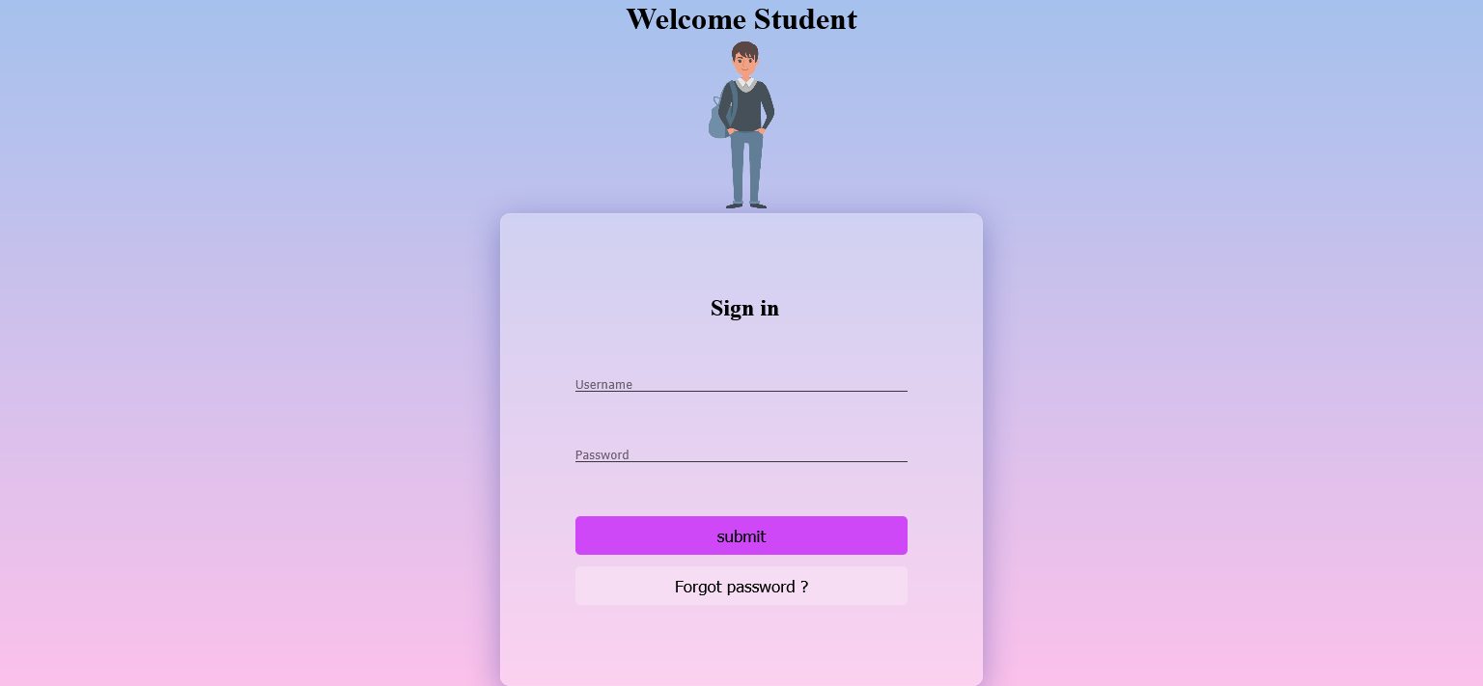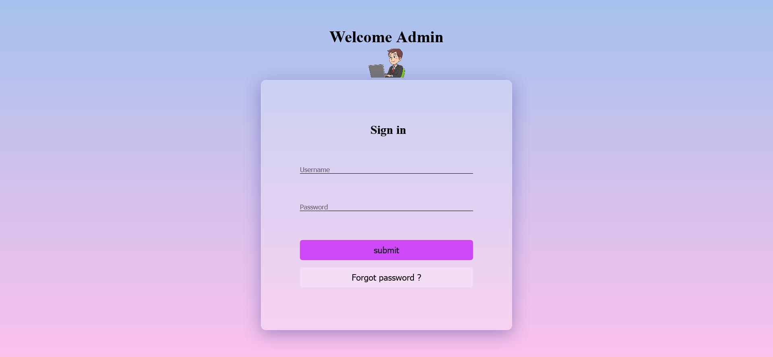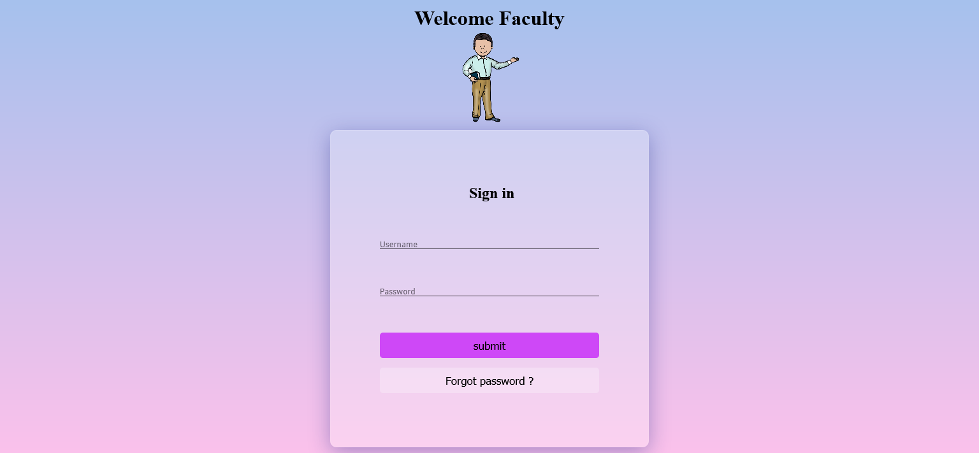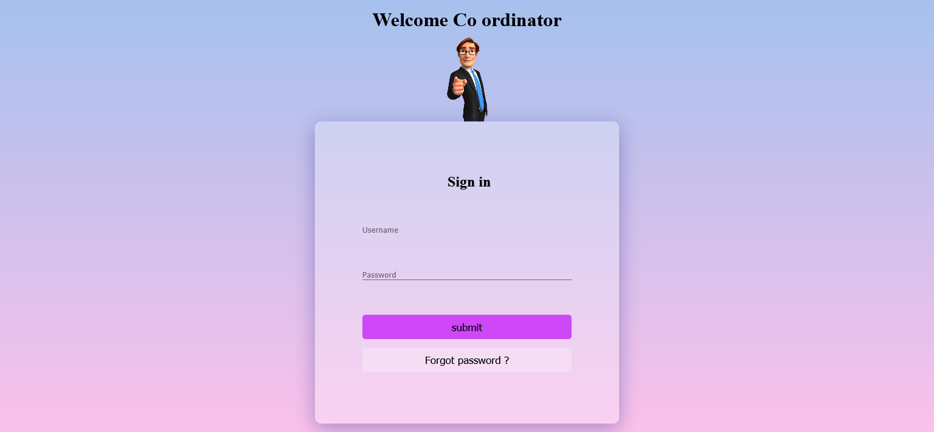

**Description:**

These are the different login pages done using single ejs file

**Code snippet:**

<!DOCTYPE html>

<html lang="en">

<head>

    <meta charset="UTF-8" />

    <meta http-equiv="X-UA-Compatible" content="IE=edge" />

    <meta name="viewport" content="width=device-width, initial-scale=1.0" />

    <title>Document</title>

    <link rel="stylesheet"  type="text/css" href="http://localhost:5000/css/style.css" />

</head>

<style>

       a{

        color: black;

    font-size: larger;

    text-align: center;

    margin-top: 5%;

    text-decoration: none;

    }

</style>

    <form method="GET", action="http://localhost:8000/">

<body>

    <div class="main-container">

        <div class="slider-container">

            <div class="left-slide">

                <div class="sign-in">

                    <h1>

                        <%= "Welcome "  +   welcome.Name %>

                    </h1>

        <img src ="  <%=welcome.image %>   "  width="100px">

                    <div class="sign-in-box">

                        <div class="head">

                            <h2>Sign in</h2>

                        </div>

                        <div class="username-field">

                            <i></i>

          <input type="text"  placeholder="Username"  name="username" />

                        </div>

                        <div class="password-field">

                            <i></i>

           <input type="password" placeholder="Password" name="password"/>

                        </div>

                        <button   formaction="/homelogin">submit</button>

                        <br><br>

<button  style="backgroundcolor:inherit;"  formaction="forgot">Forgot password ?</button>

                    </div>

                    </div>

            </div>

        </div>

    </div>

    <script src="http://localhost:5000/home.js"></script>

</body>

</html>

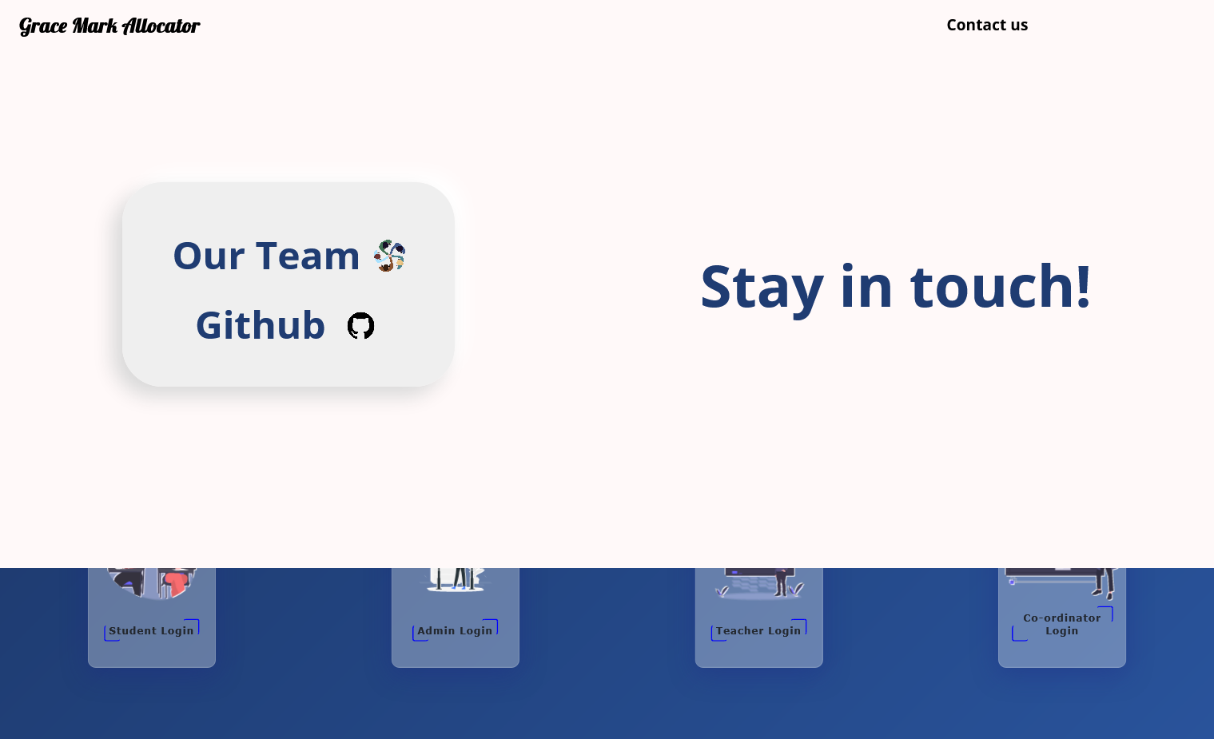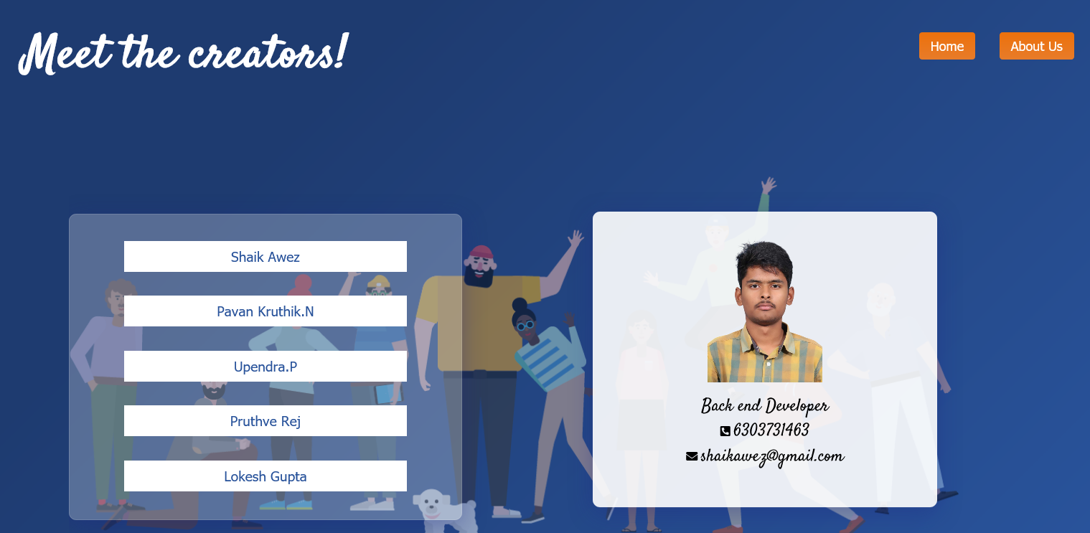

**Description:**

About us and git hub link From Home page

**Code snippet:**

<!DOCTYPE html>

<html lang="en">

<head>

    <meta charset="UTF-8" />

    <meta http-equiv="X-UA-Compatible" content="IE=edge" />

    <meta name="viewport" content="width=device-width, initial-scale=1.0" />

    <title>Contact Us</title>

    <link rel="stylesheet" href="http://localhost:5000/css/contact.css" />

    <link rel="stylesheet" href="https://cdnjs.cloudflare.com/ajax/libs/font-awesome/5.15.4/css/all.min.css" integrity="sha512-1ycn6IcaQQ40/MKBW2W4Rhis/DbILU74C1vSrLJxCq57o941Ym01SwNsOMqvEBFlcgUa6xLiPY/NS5R+E6ztJQ==" crossorigin="anonymous" referrerpolicy="no-referrer" />

</head>

<style>

.home {

position: absolute;

top: 0.8rem;

right: 10rem;

}

.home button {

background: #ed710c;

background-image: -webkit-linear-gradient(top, #ed710c, #e87c2a);

background-image: linear-gradient(to bottom, #ed710c, #e87c2a);

border-radius: 4px;

text-align: center;

color: #ffffff;

font-size: 18px;

padding: 0.5rem;

padding-right: 1rem;

padding-left: 1rem;

text-decoration: none;

border: none;

cursor: pointer;

transition: all 0.5s ease-in-out;

}

.home button:hover {

background: #3cb0fd;

text-decoration: none;

}

</style>

<body>

    <div class="header">

        <div class="messsage">

            <h1>Meet the creators!</h1>

        </div>

        <div class="about-us">

            <button>About Us</button>

        </div>

        <div class="home">

            <form method="get" action="http://localhost:8000/home">

                <button type="submit">Home</button>

            </form>

        </div>

    </div>

    <div class="img-container">

        <div class="image">

            <img src="http://localhost:5000/img/Teammates.png" />

        </div>

        <div class="creator-btns">

            <div class="click-btns">

                <a href="#item1">

                    <button>Shaik Awez</button>

                </a>

            </div>

            <div class="click-btns">

                <a href="#item2">

                    <button>Pavan Kruthik.N</button>

                </a>

            </div>

            <div class="click-btns">

                <a href="#item3">

                    <button>Upendra.P</button>

                </a>

            </div>

            <div class="click-btns">

                <a href="#item4">

                    <button>Pruthve Rej</button>

                </a>

            </div>

            <div class="click-btns">

                <a href="#item5">

                    <button>Lokesh Gupta</button>

                </a>

            </div>

        </div>

        <div class="creator-container">

            <div class="item" id="item1">

                <img src="http://localhost:5000/img/awez.png" alt="">

                <span>Back end Developer</span>

                <div class="details">

                    <i class="fas fa-phone-square-alt"></i>

                    <span>6303731463</span>

                    <div class="mail">

                        <i class="fas fa-envelope"></i>

                        <span>shaikawez@gmail.com</span>

                    </div>

                </div>

            </div>

            <div class="item" id="item2">

                <img src="http://localhost:5000/img/pavan.png" alt="">

                <span>Front end Developer</span>

                <div class="details">

                    <i class="fas fa-phone-square-alt"></i>

                    <span>8341900899</span>

                    <div class="mail">

                        <i class="fas fa-envelope"></i>

                        <span>kruthik24@gmail.com</span>

                    </div>

                </div>

            </div>

            <div class="item" id="item3">

                <img src="http://localhost:5000/img/upendra.png" alt="">

                <span>Front end Developer</span>

                <div class="details">

                    <i class="fas fa-phone-square-alt"></i>

                    <span>9182410276</span>

                    <div class="mail">

                        <i class="fas fa-envelope"></i>

                        <span>p_upendra@gmail.com</span>

                    </div>

                </div>

            </div>

            <div class="item" id="item4">

                <img src="http://localhost:5000/img/pruthve.png" alt="">

                <span>Tester</span>

                <div class="details">

                    <i class="fas fa-phone-square-alt"></i>

                    <span>9381044045</span>

                    <div class="mail">

                        <i class="fas fa-envelope"></i>

                        <span>p_pruthve@gmail.com</span>

                    </div>

                </div>

            </div>

            <div class="item" id="item5">

                <img src="http://localhost:5000/img/lokesh.png" alt="">

                <span>Tester</span>

                <div class="details">

                    <i class="fas fa-phone-square-alt"></i>

                    <span>8142838171</span>

                    <div class="mail">

                        <i class="fas fa-envelope"></i>

                        <span>g_lokesh@gmail.com</span>

                    </div>

                </div>

            </div>

        </div>

    </div>

    <script src="http://localhost:5000/js/contact.js"></script>

</body>

</html>

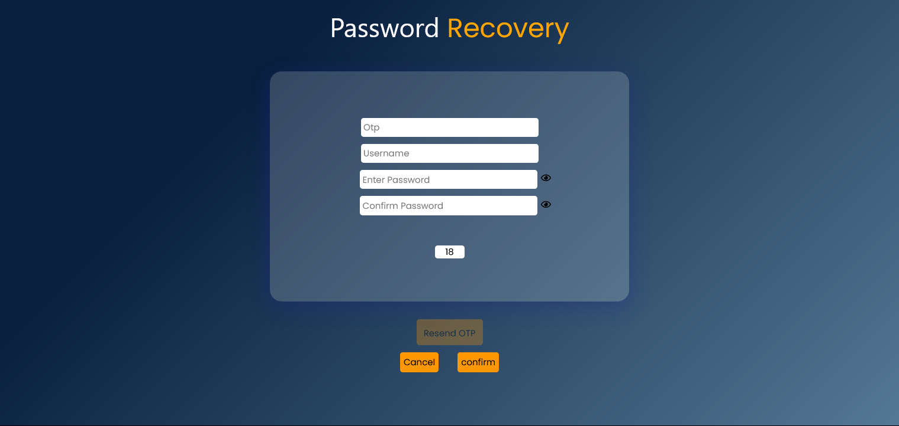

**Description:**

Forgot password page , with the help of otp generated to mobile

can reset password , done validations for each input feild

**Code snippet:**

<!DOCTYPE html>

<html lang="en">

<head>

  <title>OTP</title>

  <meta name="viewport" content="width=device-width, initial-scale=1">

  <link rel="stylesheet" href="https://www.w3schools.com/w3css/4/w3.css">

  <link rel="stylesheet" href="https://cdnjs.cloudflare.com/ajax/libs/font-awesome/5.13.0/css/all.min.css">

<body>

  <header>

    <h2>Password <span>Recovery</span></h2>

  </header>

  <form method="GET", action="http://localhost:8000/">

      <div class="inputs">

<input type="text" placeholder="Otp" name="otp">

<input type="text" placeholder="Username" name="uname1">

<div class="password">

<input type="password" placeholder="Enter Password"   name="pwd" id="pwd">

<em class="far fa-eye" onclick="password()"></em>

        </div>

        <div class="confirm-password">

<input type="password" placeholder="Confirm Password"   name="cpwd" id="cpwd">

          <em class="far fa-eye" onclick="confirmpassword()"></em>

        </div>

        <div id="countdown"></div>

      </div>

    <script>

      function password() {

        var x = document.getElementById("pwd");

        if (x.type === "password") {

          x.type = "text";

        } else {

          x.type = "password";

        }

      }

      function confirmpassword() {

        var x = document.getElementById("cpwd");

        if (x.type === "password") {

          x.type = "text";

        } else {

          x.type = "password";

        }

      }

    </script>

    <button class="w3-btn w3-orange" id="mybutton" formaction="/otp">Resend OTP</button> <br><br>

    <p>

<button  formaction="/home" , class="w3-btn w3-orange">Cancel</button>   &nbsp; &nbsp;

<button type="submit" , class="w3-btn w3-orange">confirm</button> <br><br>

    <p></p>

    <script>

      const htmlBtn = document.getElementById("mybutton");

      htmlBtn.disabled = true;

    </script>

    <script>

      alert("otp sent succesfully")

      var timeleft = 20;

      var downloadTimer = setInterval(function () {

        if (timeleft <= 0) {

          clearInterval(downloadTimer);

          document.getElementById("countdown").innerHTML = " ", htmlBtn.disabled = false;

        } else {

          document.getElementById("countdown").innerHTML = timeleft;

        }

        timeleft -= 1;

      }, 1000);

    </script>

  </form>

</body>

</html>

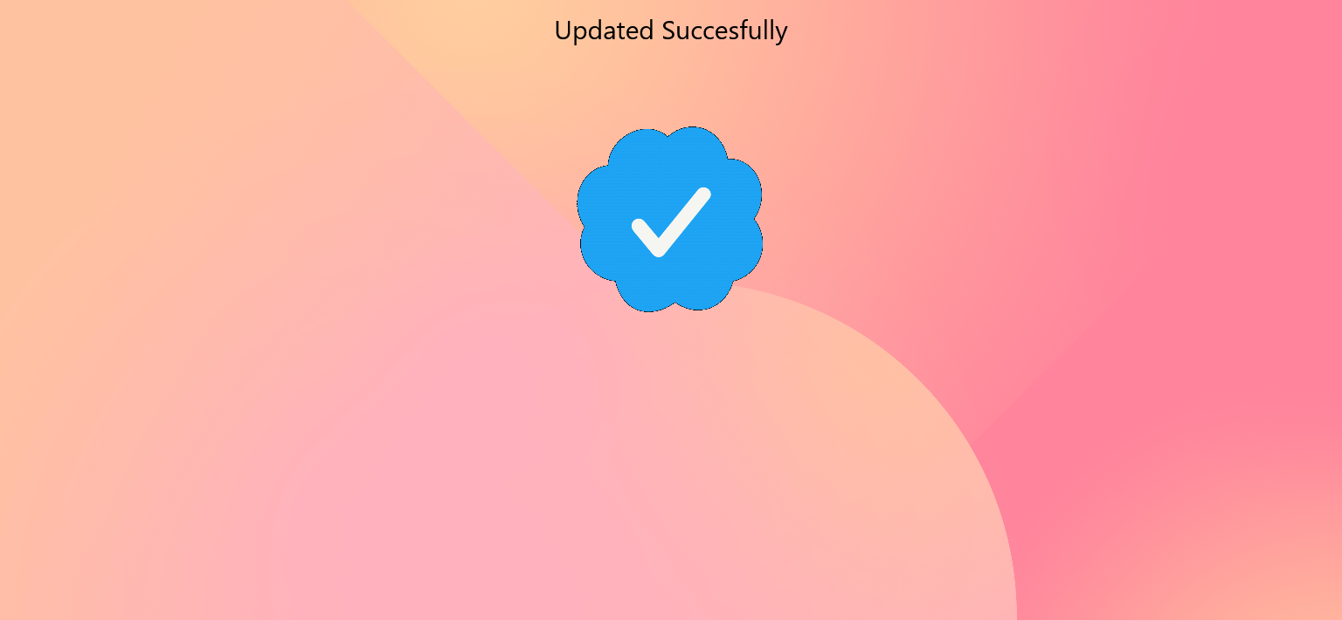

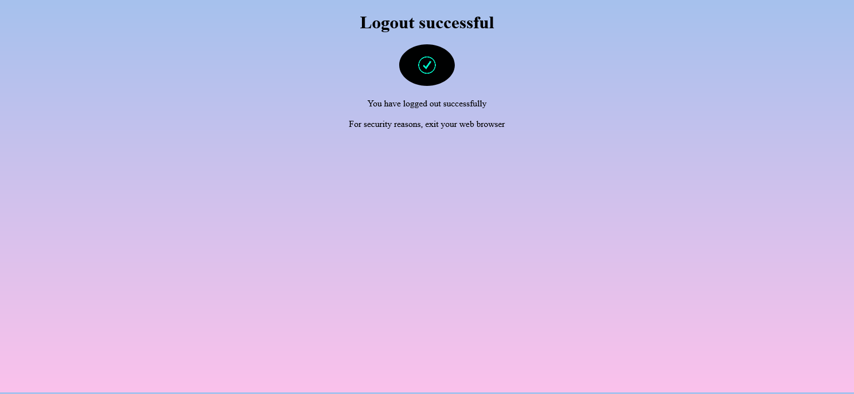

**Description :**

Basic logout page (Backward prevention script added), updation Acknowledge page after password reset

**Code snippet:**

<!DOCTYPE html>

<html lang="en">

<head>

<meta charset="UTF-8">

<meta name="viewport" content="width=device-width, initial-scale=1.0">

<style>

body{

    background-image: linear-gradient(to top, #fbc2eb 0%, #a6c1ee 100%);

    height: 95.5vh;

    justify-content: center;

    align-items: center;

     text-align: center;

}

img {

  border-radius: 50%;

}

</style>

<title>Logout</title>

<form method="GET", action="http://localhost:8000/">

</head>

<body>

    <script type="text/javascript">

        window.history.forward();

        function noBack()

        {

            window.onbeforeunload = function() { return "Your work will be lost."; };

        }

    </script>

<body onLoad="noBack();" onpageshow="if (event.persisted) noBack();" onUnload="">

<h1>Logout successful </h1>

<img src="https://i.pinimg.com/originals/70/a5/52/70a552e8e955049c8587b2d7606cd6a6.gif" width="100" alt="image not available"></img></br><br>

<p1> You have logged out successfully </p1><br>

 <br>

<p1> For security reasons, exit your web browser </p1> <br> </br>

<script type = "text/javascript" >

function preventBack() { window.history.forward(); }

setTimeout("preventBack()", 0);

window.onunload = function () { null };

</script>

</body>

</html>

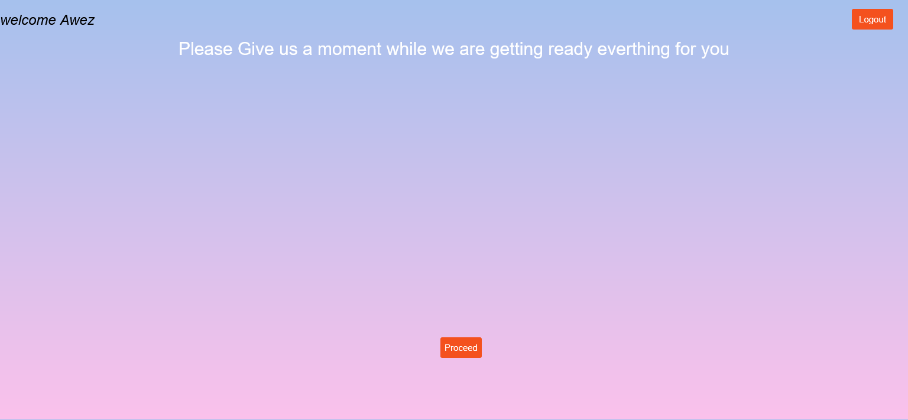

**Description:**

Welcome page with name , Fetched According to Login id with an Loading Animation

**Code snippet:**

<!DOCTYPE html>

<html lang="en">

<head>

    <meta charset="UTF-8">

    <meta http-equiv="X-UA-Compatible" content="IE=edge">

    <link rel="stylesheet" href="css/welcome.css">

<body>

<form method="GET", action="http://localhost:8000/">

        <% loginwelcome.forEach(function (login) { %>

           <h1>

             <%= "welcome  "  + login.name%>

            <% }) %>

         </h1>

       <h2> Please Give us a moment while  we are getting ready everthing for you</h2>

</tbody>

</table>

<button class="logout" formaction="/warning">Logout</button>

<button class="proceed" id="proceed" formaction="/data">Proceed</button>

</body>

</html>

**Evaluation sheet:**

|  |  |  |  |  |
| --- | --- | --- | --- | --- |
| Roll No | Technology | Max Marks | Marks Awarded | Total (30) |
| 18117 | HTML  CSS | 10  10 |  |  |
| 18136 | HTML  CSS | 10  10 |  |  |
| 18137 | HTML  CSS | 10  10 |  |  |
| 18138 | HTML  CSS | 10  10 |  |  |
| 18148 | HTML  CSS | 10  10 |  |  |
|  | Project Documentation | 10 |  |  |

**B. Tech. project Grace Marks Allocator– G 22**

**PROJECT REPORT-II**

***Submitted by***

|  |  |  |
| --- | --- | --- |
| **S. No** | **Name** | **Roll Number** |
| 1. | G Lokesh | CB.EN.U4CSE18117 |
| 2. | P Pruthve Rej | CB.EN.U4CSE18136 |
| 3. | N Pavan Kruthik | CB.EN.U4CSE18137 |
| 4. | P Upendra | CB.EN.U4CSE18138 |
| 5. | Sk Awez | CB.EN.U4CSE18148 |

***is fulfilment of the requirements for the Course – 15CSE376 (Net Centric Programming)***

**BACHELOR OF TECHNOLOGY IN**

**COMPUTER SCIENCE AND ENGINEERING**



**DEPARTMENT OF COMPUTER SCIENCE AND ENGINEERING**

**AMRITA SCHOOL OF ENGINEERING**

**AMRITA VISHWA VIDYAPEETHAM**

**COIMBATORE -641112**

**October 2021**

**Table of Contents**

|  |  |  |
| --- | --- | --- |
| **S.No** | **Section Name** | **Page Number** |
| 1 | JDBC | 3 |
| 2 | Servlet | 4 |
| 3 | ER diagram | 6 |
| 4 | Architecture diagram | 7 |
| 5 | Table specifications | 8 |
| 6 | Functionalities using servlets | 11 |
| 7 | Database connectivity | 12 |
| 8 | Validation | 14 |

**Technologies Learnt:**

**Servlets**

Servlets are the Java programs that run on the Java-enabled web server or application server

They are used to handle the request obtained from the web server, process the request, produce the response, then send a response back to the web server.  
Properties of Servlets are as follows:

● Servlets work on the server-side.

● Servlets are capable of handling complex requests obtained from the web server.

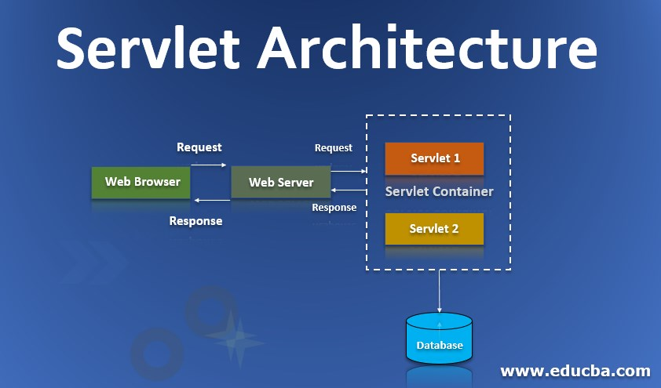

**Execution of Servlets involves six basic steps:**

1. The clients send the request to the web server.  
2. The web server receives the request.  
3. The web server passes the request to the corresponding servlet.  
4. The servlet processes the request and generates the response in  
the form of output.  
5. The servlet sends the response back to the web server.  
6. The web server sends the response back to the client and the client  
browser displays it on the screen.

**JDBC**

JDBC stands for Java Database Connectivity. JDBC is a Java API to  
connect and execute the query with the database. It is a part of Java SE (Java Standard Edition). JDBC API uses JDBC drivers to connect with the database.

We can use JDBC API to access tabular data stored in any relational  
database. With the help of JDBC API, we can save, update, delete and fetch data from the database.  
We can use JDBC API to handle database using Java program and can perform the following activities:  
1. Connect to the database  
2. Execute queries and update statements to the database  
3. Retrieve the result received from the database.

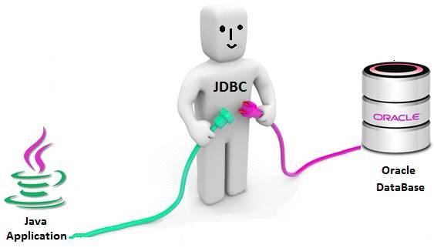

**ER Diagram:**

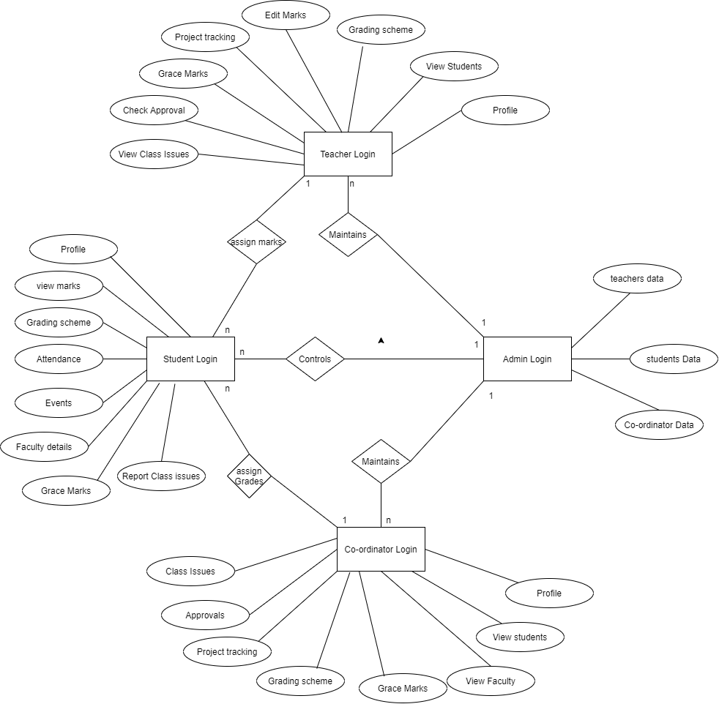

**Architecture diagram:**

**Table Specifications:**

**1)Users**

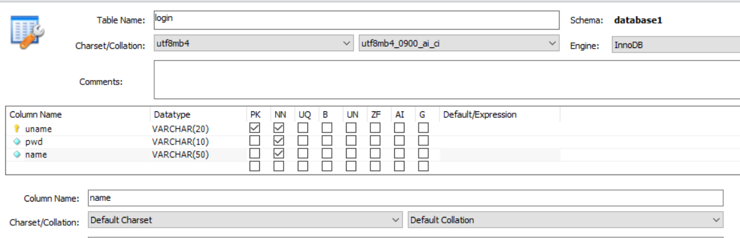

**2)Profile**

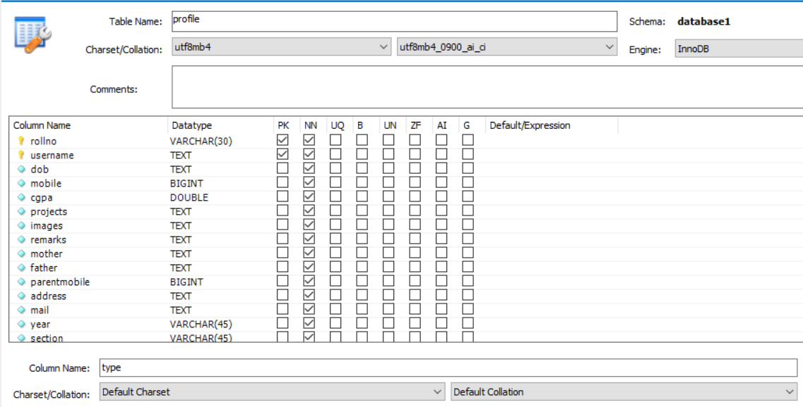

**3)** **Approval**

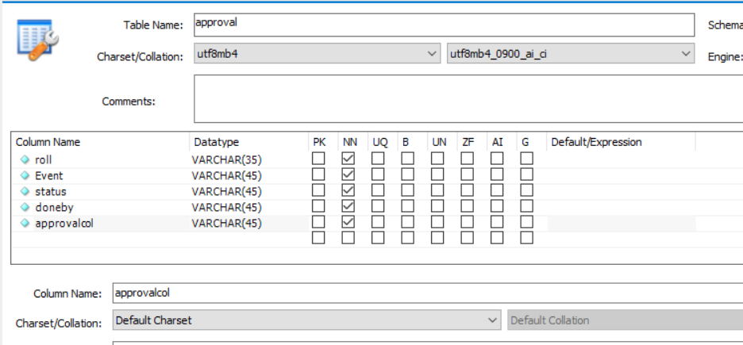

**4)Project Tracking**

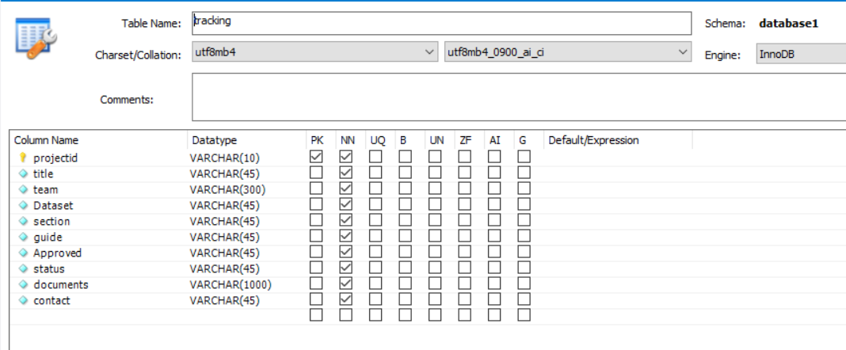

**5)Otp**

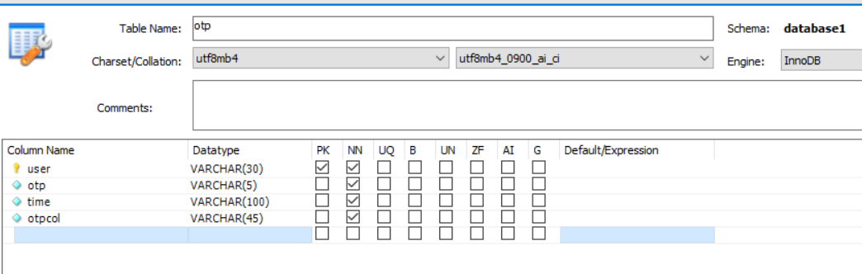

**6)Attendance**

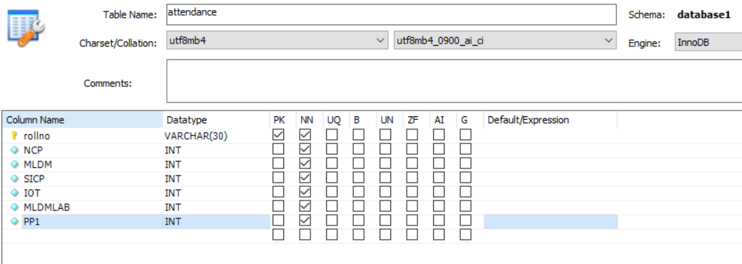

**Functionalities using servlets**

1. **Login Action**
2. Path :/login
3. Method: Get
4. Input: username, password
5. **Enroll Student**

a)Path:/enroll

b)Method:Get

c)Input:Students Data

1. **Marks Re enter**

a)Path:/editmarks

b)Method:Get

c)Input:Marks Record

1. **Approval**

a)Path:/approval

b)Method:Get

c)Input:Co Ordinator Approval

1. **Class Issues**

a)Path:/issue

b)Method:Get

c)Input:Students Feedback

1. **Admin Access**

a)Path:/admin

b)Method:Get

c)Input:Login Credentials

1. **Block User**

a)Path:/block

b)Method:Get

c)Input:Reamark , Rollno

1. **Event Mark**

a)Path:/graceedit

b)Method:Get

c)Input:Mark , Eventype

1. **Grade**

a)Path:/Grade

b)Method:Get

c)Input:Mark , Subcode

**Database connectivity**

**Java:**

    System.out.println("\n\n***** MySQL JDBC Connection Testing *****");

           Connection conn = null;

           try

           {

           Class.forName ("com.MySQL.jdbc.Driver").newInstance ();

               String userName = "root";

               String password = "Awez@0987";

               String url = "jdbc:MySQL://localhost/database1";

               conn = DriverManager.getConnection (url, userName, password);

               System.out.println ("\nDatabase Connection Established...");

           }

          catch (Exception ex)

           {

               System.err.println ("Cannot connect to database server");

               ex.printStackTrace();

           }

**Javascript:**

var mysql = require('mysql');

var con = mysql.createConnection({

  host: "localhost",

  user: "root",

  password: "Awez@0987"

});

con.connect(function(err) {

  if (err) throw err;

  console.log("Connected!");

});

**Insertion:**

String query="insert into approval (roll , Event , status) values (?,?,?,?,?,?)";

   PreparedStatement st=con.prepareStatement(query);

   st.setString(1,rollno);

   st.setString(2,event);

   st.setString(3,status);

**Updation:**

String query="UPDATE database1.marks SET  "+ subcode + "= ? WHERE (rollno = ?) ";

   PreparedStatement st=con.prepareStatement(query);

   st.setString(1,mark);

   st.setString(2,rollno);

   int check=st.executeUpdate();

   return check;

**Validation:**

   String username=  req.getParameter("username");

   String password= req.getParameter("password");

   LoginDao dao = new LoginDao();

   try {

       if(dao.connectdb(username, password)) {

           HttpSession session = req.getSession();

           res.sendRedirect("http://localhost:8000/Student");

       }else {

           res.sendRedirect("http://localhost:8000/?username=+&password=+");

       }

**Validation**

if(username != undefined && password != undefined) {

fs.truncate('currentlogin.txt', 0, function() {

console.log("File Content Deleted");

});

fs.readFile('block.txt', 'utf-8', (err, data) => { if (err) throw err;

if(username==data){

res.send("Your account is blocked ..pls login after 24hrs");

}else{

var test = 0;

var pd=password;

fs.readFile('logintype.txt', 'utf-8', (err, data) => {

var sqlquery='SELECT * from ';

sqlquery +=data;

mycon.query(sqlquery, function (error,login, fields) {

if (error) throw error;

var length = login.length;

var m=null;

for(var i = 0; i < length; i++){

if (login[i].uname==username){

m=i;

}

}

if(m==null){

res.sendfile("oops.html");

}else{

if(login[m].pwd==password){

test=1

fs.appendFile('currentlogin.txt', username , (err) => {

if (err) throw err;

const sql5=`INSERT INTO database1.currentlogin (user) VALUES ('${username}')`;

mycon.query(sql5, function (err1, result) {

if (err1) throw err1;

console.log(result);

});

})

console.log(test);

if(test==1){   res.redirect("/loginwelcome"); }

**Evaluation sheet:**

|  |  |  |  |  |
| --- | --- | --- | --- | --- |
| Roll No | Technology | Max Marks | Marks Awarded | Total (30) |
| 18117 | Servlet  JDBC | 10  10 |  |  |
| 18136 | Servlet  JDBC | 10  10 |  |  |
| 18137 | Servlet  JDBC | 10  10 |  |  |
| 18138 | Servlet  JDBC | 10  10 |  |  |
| 18148 | Servlet  JDBC | 10  10 |  |  |
|  | Project Documentation | 10 |  |  |

**B. Tech. project Grace Marks Allocator– G 22**

**PROJECT REPORT-III**

***Submitted by***

|  |  |  |
| --- | --- | --- |
| **S. No** | **Name** | **Roll Number** |
| 1. | G Lokesh | CB.EN.U4CSE18117 |
| 2. | P Pruthve Rej | CB.EN.U4CSE18136 |
| 3. | N Pavan Kruthik | CB.EN.U4CSE18137 |
| 4. | P Upendra | CB.EN.U4CSE18138 |
| 5. | Sk Awez | CB.EN.U4CSE18148 |

***is fulfilment of the requirements for the Course – 15CSE376 (Net Centric Programming)***

**BACHELOR OF TECHNOLOGY IN**

**COMPUTER SCIENCE AND ENGINEERING**



**DEPARTMENT OF COMPUTER SCIENCE AND ENGINEERING**

**AMRITA SCHOOL OF ENGINEERING**

**AMRITA VISHWA VIDYAPEETHAM**

**COIMBATORE -641112**

**November 2021**

**Table of Contents**

|  |  |  |
| --- | --- | --- |
| **S.No** | **Section Name** | **Page Number** |
| 1 | Abstract | 3 |
| 2 | Technologies Used | 4 |
| 3 | Implementation | 6 |
| 4 | Ouput | 7 |
| 5 | Validation | 8 |
| 6 | Evaluation | 11 |

**Abstract**

**Technologies Used**

**HTML**

HTML is the language for describing the structure of Web pages. HTML gives authors the means to:  
● Publish online documents with headings, text, tables, lists, photos, etc.  
● Retrieve online information via hypertext links, at the click of a button.  
● Design forms for conducting transactions with remote services, for use in searching for information, making reservations, ordering products, etc.  
● Include spread-sheets, video clips, sound clips, and other applications directly in their  
documents

With HTML, authors describe the structure of pages using markup. The elements of the  
language label pieces of content such as “paragraph,” “list,” “table,” and so on

**CSS:**

Cascading Style Sheets (CSS) is a stylesheet language used to describe the presentation of a document written in HTML or XML. CSS describes how elements should be rendered on screen, on paper, in speech, or on other media. CSS is used to style and layout web pages — for example, to alter the font, colour, size, and spacing of your content, split it into multiple columns, or add animations and other decorative features. This module provides a gentle beginning to your path towards CSS mastery with the basics of how it works, what the syntax looks like, and how you can start using it to add styling to HTML.

**JavaScript:**

JavaScript (JS) is a lightweight, interpreted, or just-in-time compiled programming language with first-class functions. While it is most well-known as the scripting language for Web pages, many non-browser environments also use it, such as Node.js, Apache CouchDB and Adobe Acrobat. JavaScript is a prototype-based, multi-paradigm, single-threaded, dynamic language, supporting object-oriented, imperative, and declarative styles.

**Embedded JavaScript:**

You can embed JavaScript in an HTML document in the following ways: As statements and functions within a <SCRIPT> tag. ... See "Specifying a file of JavaScript code". By specifying a JavaScript expression as the value for an HTML attribute. See "Using JavaScript expressions as HTML attribute values".

**Servlets**

Servlets are the Java programs that run on the Java-enabled web server or application server

They are used to handle the request obtained from the web server, process the request, produce the response, then send a response back to the web server.  
Properties of Servlets are as follows:

● Servlets work on the server-side.

● Servlets are capable of handling complex requests obtained from the web server.



**Execution of Servlets involves six basic steps:**

1. The clients send the request to the web server.  
2. The web server receives the request.  
3. The web server passes the request to the corresponding servlet.  
4. The servlet processes the request and generates the response in  
the form of output.  
5. The servlet sends the response back to the web server.  
6. The web server sends the response back to the client and the client  
browser displays it on the screen.

**JDBC**

JDBC stands for Java Database Connectivity. JDBC is a Java API to  
connect and execute the query with the database. It is a part of Java SE (Java Standard Edition). JDBC API uses JDBC drivers to connect with the database.

We can use JDBC API to access tabular data stored in any relational  
database. With the help of JDBC API, we can save, update, delete and fetch data from the database.  
We can use JDBC API to handle database using Java program and can perform the following activities:  
1. Connect to the database  
2. Execute queries and update statements to the database  
3. Retrieve the result received from the database.



**Implementation**

**Login Servlet :**

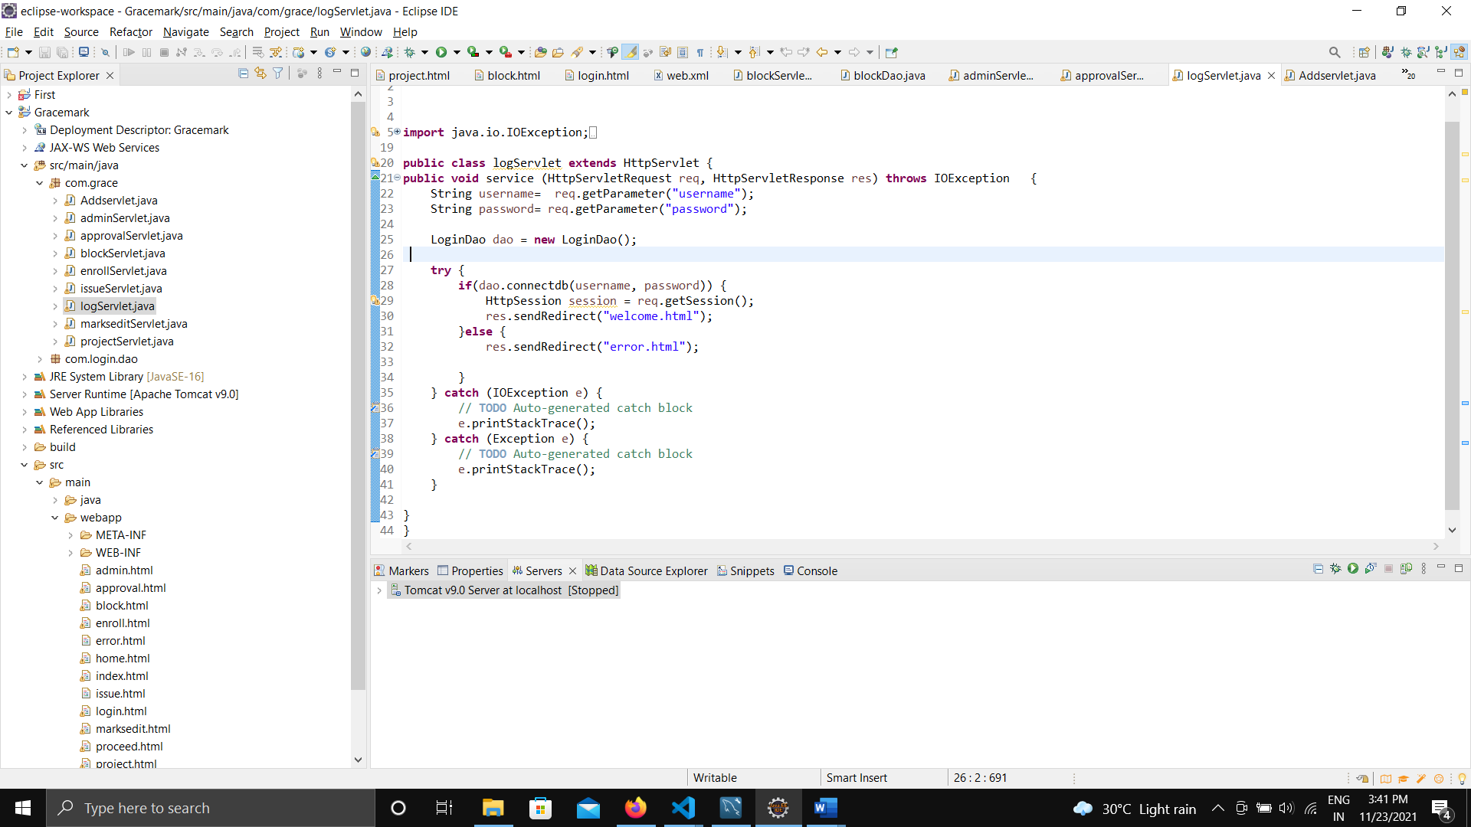

**JDBC:**

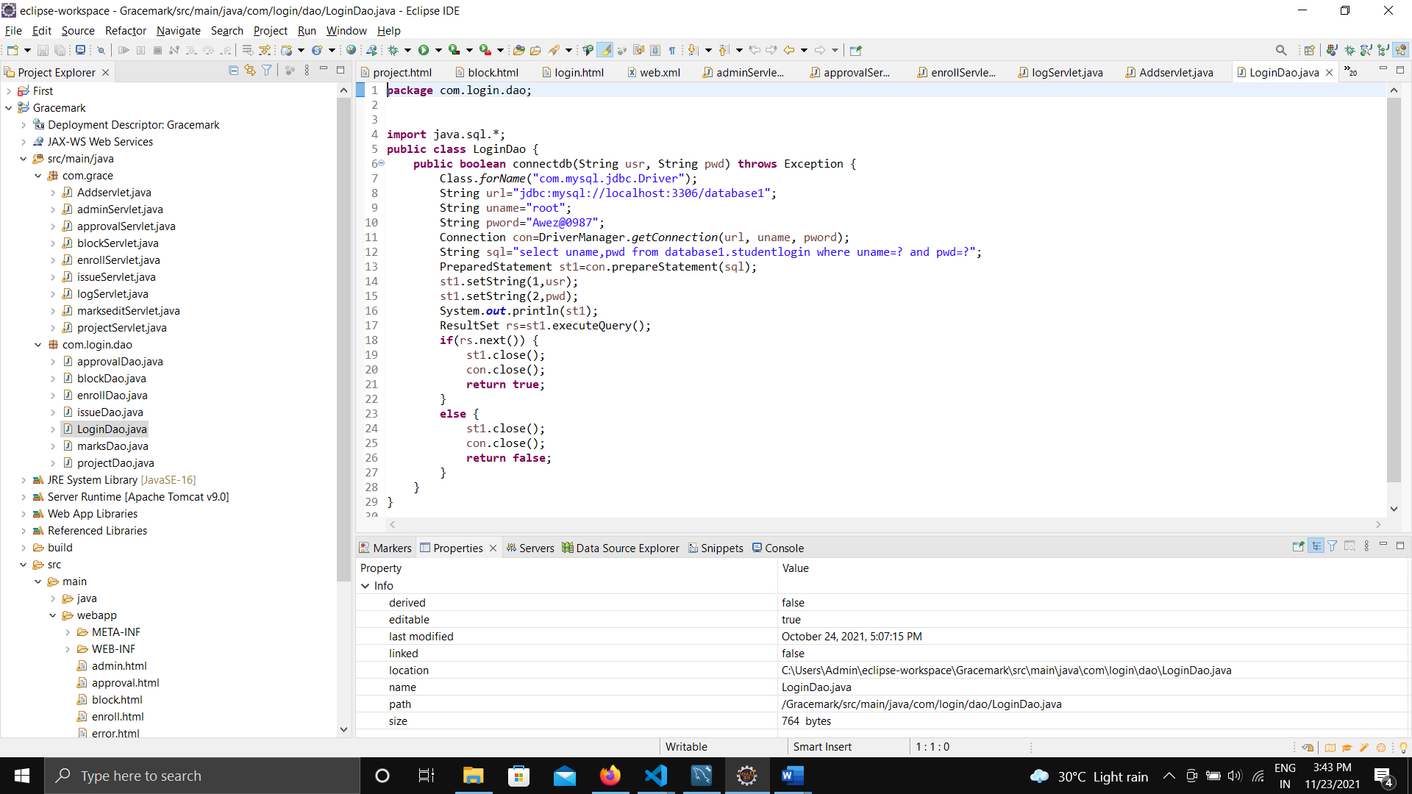

**Enroll Servlet :**

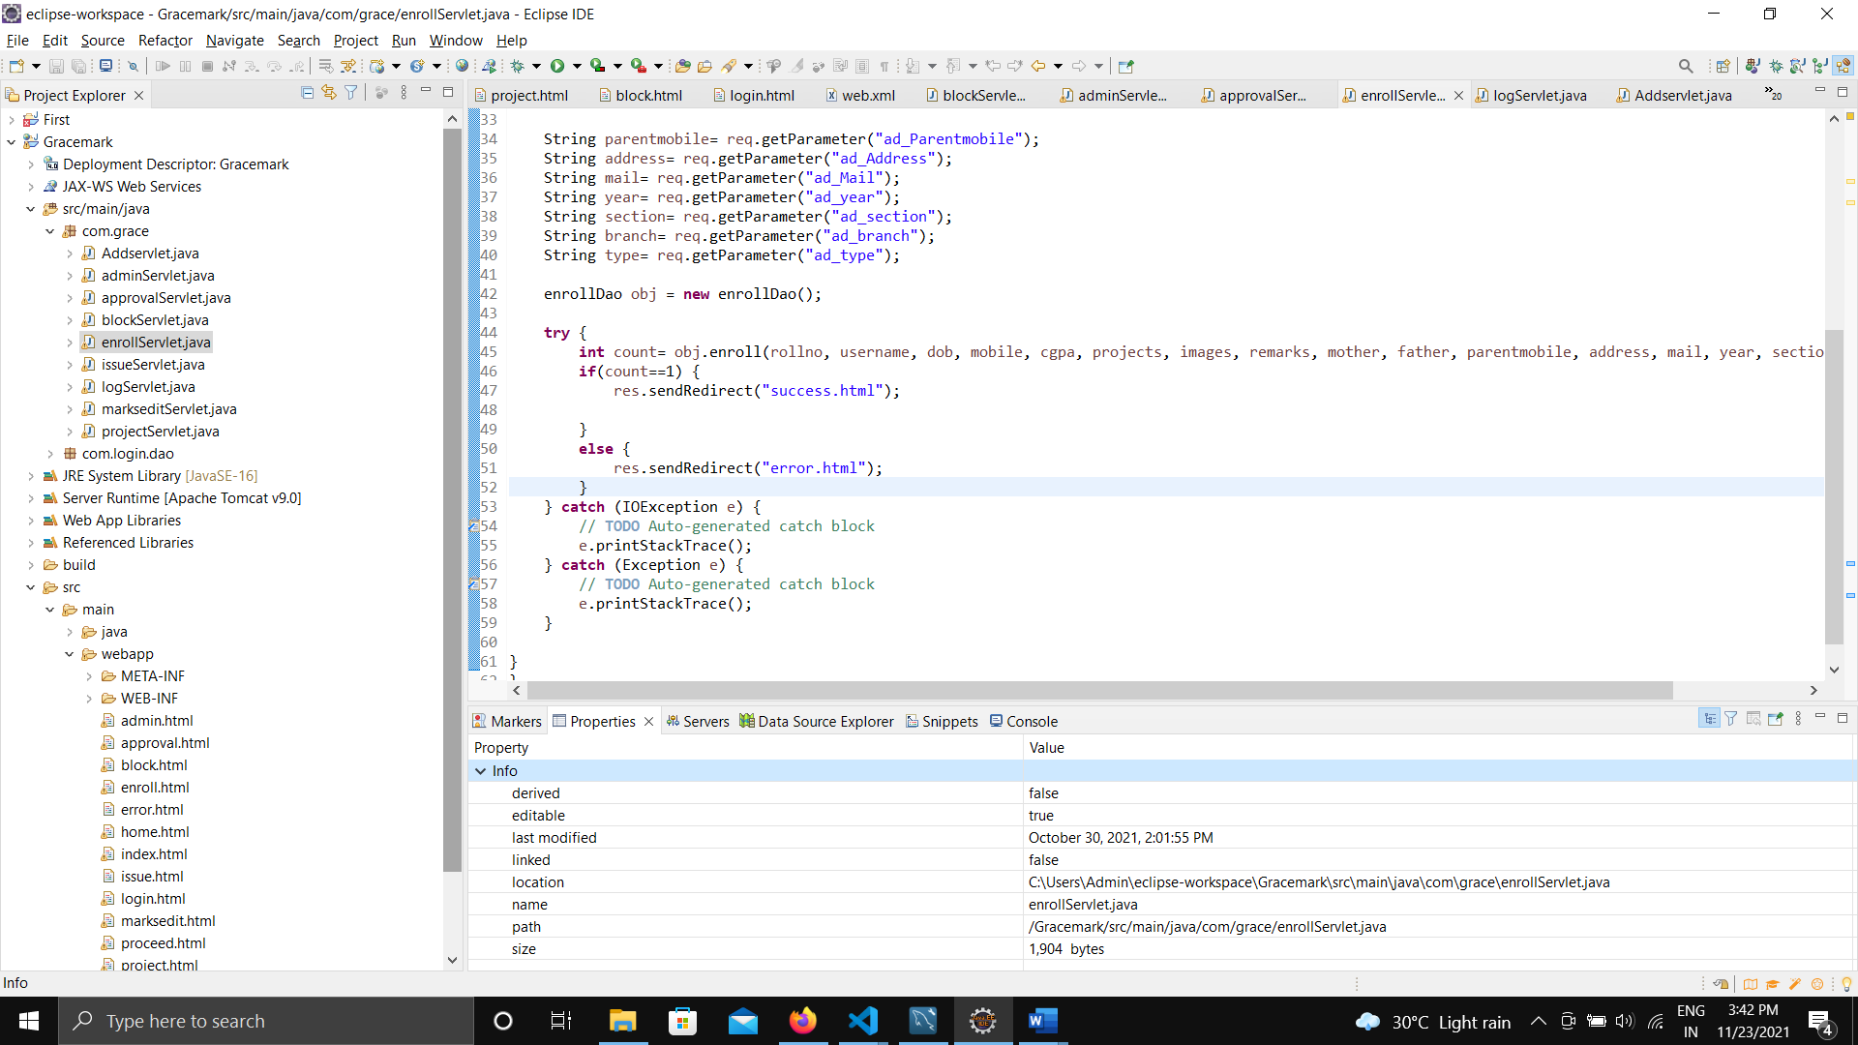

**JDBC:**

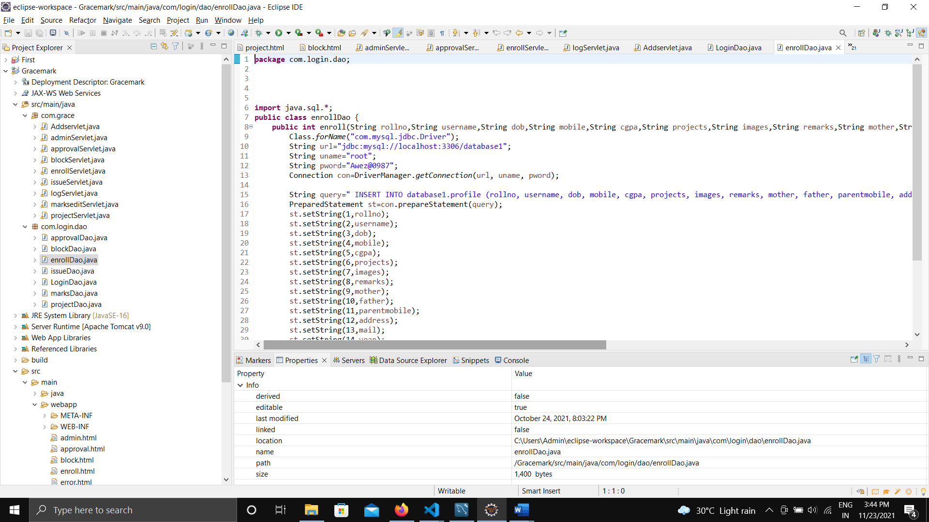

**Project Servlet :**

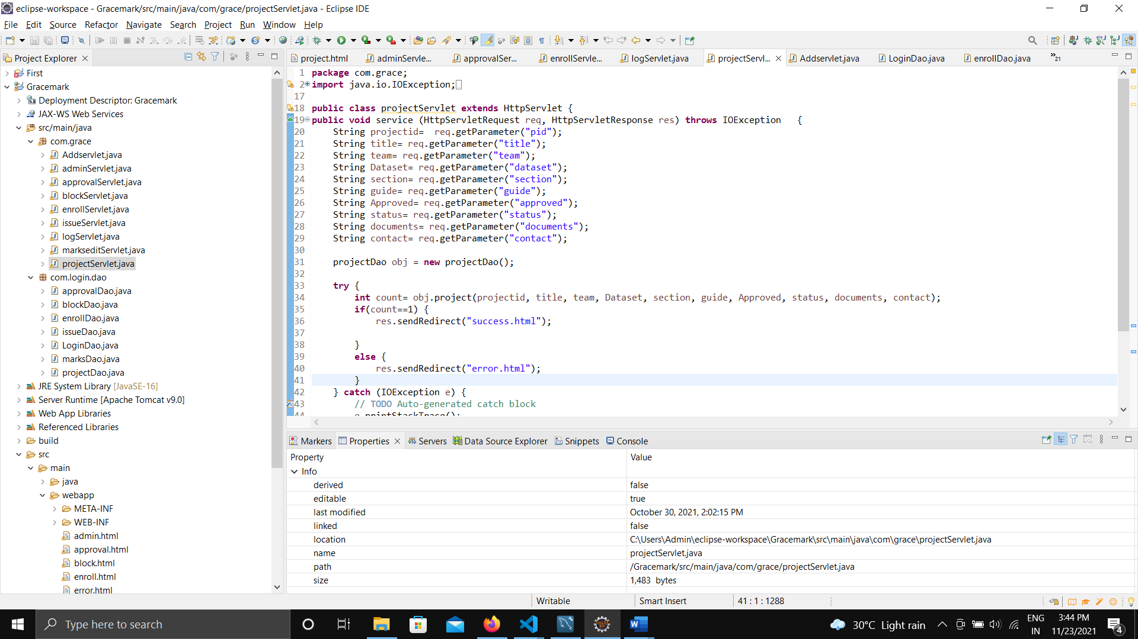

**JDBC:**

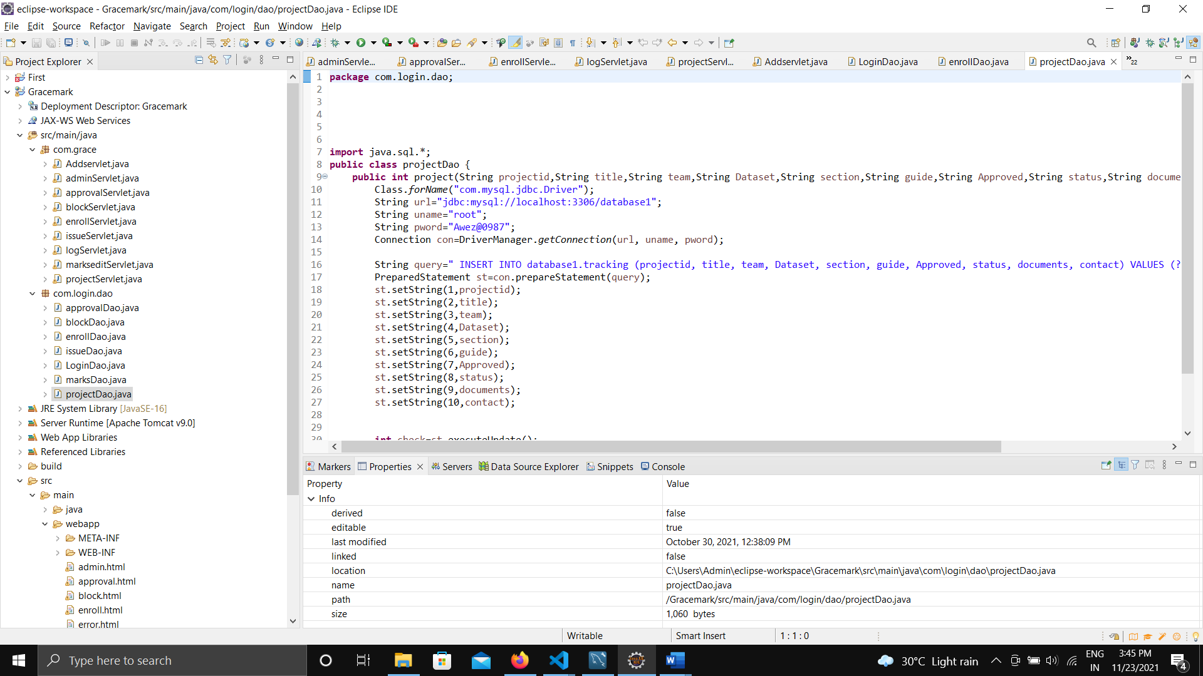

**Approval**

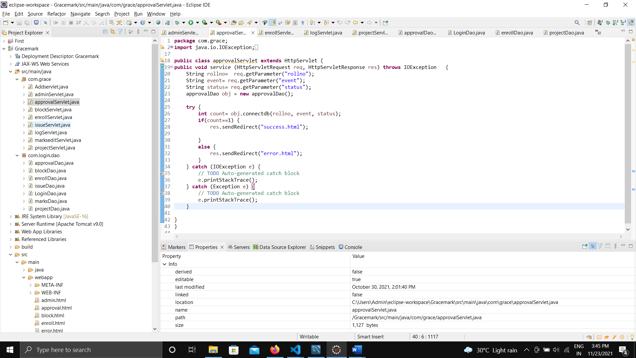

**Block User**

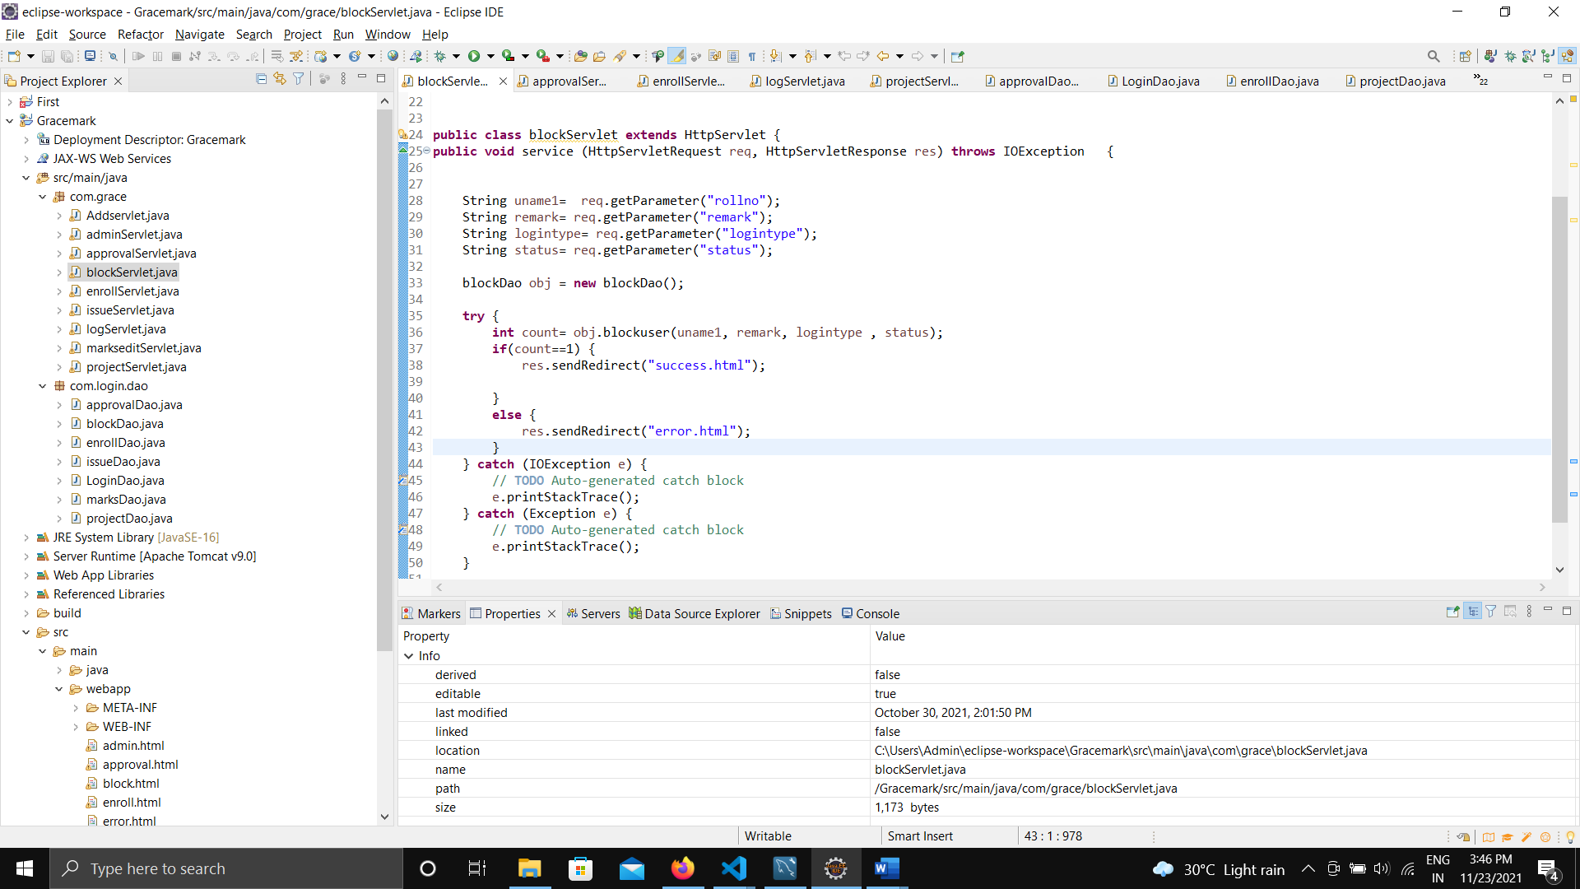

**Active Login :**

            <div class="container">

        <table class="table table-striped">

        <% activelogins.forEach(function (login) { %>

       <tr>

        <td><%=  login.username %>     </td>

        <td><%=  login.rollno %>     </td>

        <td> <%= login.mobile %>      </td>

        <td> <%= login.mail %>      </td>

        <td>  <img src="<%=login.images%>" width="150" alt="image not available"></img> </td>

      </tr>

        <% }) %>

**Attendance:**

        <% attendance.forEach(function (students) { %>

      <tr>

          <th>  Course Code   </th>

          <th> Course Name </th>

          <th> Attendace in % </th>

      </tr>

      <tr>

          <td>15CSE376</td>

          <td>Net Centric Programming</td>

          <td ><%=students.NCP%> </td></tr>

          <td>15CSE401</td>

          <td>Machine Learning and Data Mining</td>

          <td ><%=students.MLDM%> </td></tr>

          <td>15CSE402</td>

          <td>Structure and Interpretation of Computer Programs</td>

          <td ><%=students.SICP%> </td></tr>

          <td>15CSE480</td>

          <td>Internet of Things</td>

          <td ><%=students.IOT%> </td></tr>

          <td>15CSE481</td>

          <td>Machine Learning and Data Mining Lab.</td>

          <td ><%=students.MLDMLAB%> </td></tr>

          <td>15CSE495</td>

          <td>Project Phase I</td>

          <td ><%=students.PP1%> </td></tr> <% }) %>

        </center>

**Retriving Student Details**

var obj1 = {};

app.set('views',path.join(__dirname,'views'));

app.set('view engine', 'ejs');

app.get('/students', function(req, res) {

fs.readFile('currentlogin.txt', 'utf-8', (err, data) => {

if (err) throw err;

mycon.query(`  SELECT * FROM database1.profile where type="student"; `, function(err, result) {

        if(err){

        throw err;

        } else {

        obj1 = {students_details: result};

        res.render('students_details', obj1);

       // console.log(obj1);

        }

        });

});

});

**Project Dashboard**

app.get('/trackingdashboard', function(req, res) {

fs.readFile('currentlogin.txt', 'utf-8', (err, data) => {

if (err) throw err;

mycon.query(`  SELECT * FROM database1.tracking , profile where (profile.username = tracking.guide) `, function(err, result) {

if(err){

throw err;

} else {

obj1 = {trackingdashboard: result};

res.render('trackingdashboard', obj1);

// console.log(obj1);

}

});

});

});

**Faculty Details**

app.get('/faculty_details', function(req, res) {

var obj2={}

mycon.query(` SELECT * FROM database1.profile where type="faculty"; `, function(err, result) {

if(err){

throw err;

} else {

obj2 = {faculty_details: result};

res.render('faculty_details', obj2);

}});

});

**Profile**

fs.readFile('logintype.txt', 'utf-8', (err, data1) => {

fs.readFile('currentlogin.txt', 'utf-8', (err, data) => {

if (err) throw err;

mycon.query( `SELECT * FROM  profile where  ( profile.rollno = '${data}') ` , function(err, result) {

if(err){

throw err;

} else {

obj = {upload: result};

res.render('upload', obj);

}

});

});

})

})

**Erasing Current user from database when logged out**

app.get('/logout', function(req, res){

res.sendfile("logout.html");

fs.readFile('currentlogin.txt', 'utf-8', (err, data) => {

if (err) throw err;

mycon.query(  `truncate table database1.currentlogin `,function(err,result){

if(err) throw err;

// console.log(result);

});

**Retriving Marks**

app.get('/selfmarks', function(req, res) {

var obj2={}

fs.readFile('currentlogin.txt', 'utf-8', (err, data) => {

if (err) throw err;

mycon.query(` SELECT * FROM database1.marks where rollno =  '${data}'; `, function(err, result) {

if(err){

throw err;

} else {

obj2 = {marks: result};

res.render('marks', obj2);

}});

});

});

**Uploading Documents Function**

http.createServer(function (req, res) {

  if (req.url == '/fileupload') {

    var form = new formidable.IncomingForm();

    form.parse(req, function (err, fields, files) {

      var oldpath = files.filetoupload.path;

      var newpath = 'C:/Users/Admin/Desktop/Ncp/Project/Upload/' + files.filetoupload.name;

      fs.rename(oldpath, newpath, function (err) {

        if (err) throw err;

        res.write('File uploaded and moved!');

        res.end();

      });

 });

  } else {

    res.writeHead(200, {'Content-Type': 'text/html'});

    res.write('<form action="fileupload" method="post" enctype="multipart/form-data">');

    res.write('<input type="file" name="filetoupload"><br>');

    res.write('<input type="submit">');

    res.write('</form>');

    return res.end();

  }

}).listen(8080);

**Output**

**Home page:**

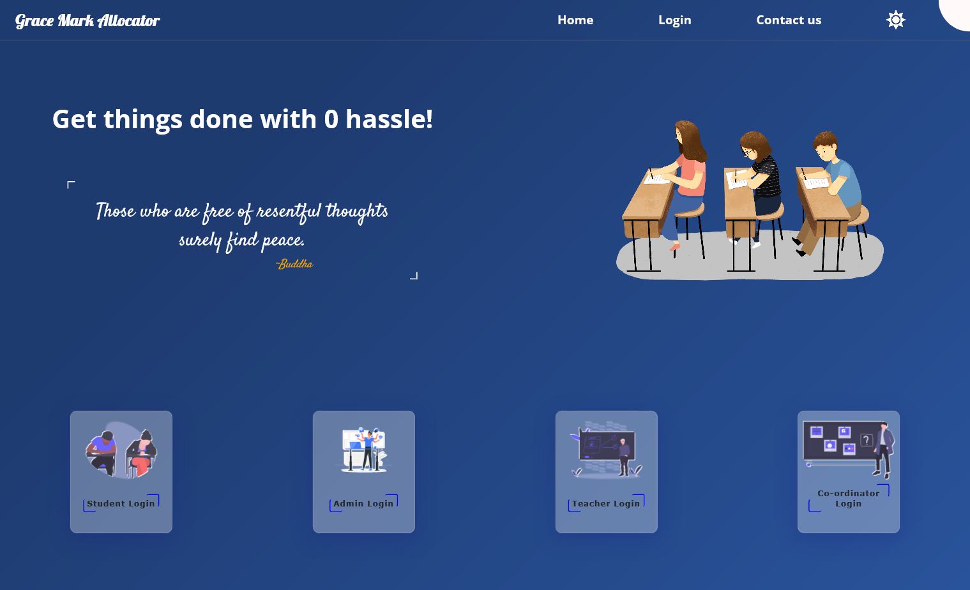**Login :**

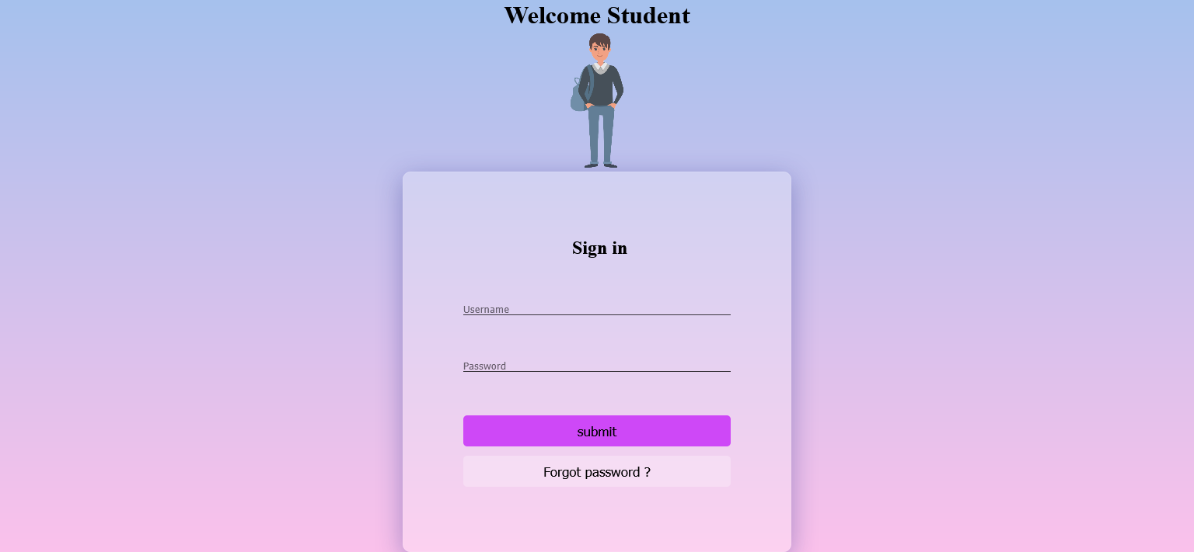

**Welcome page:**

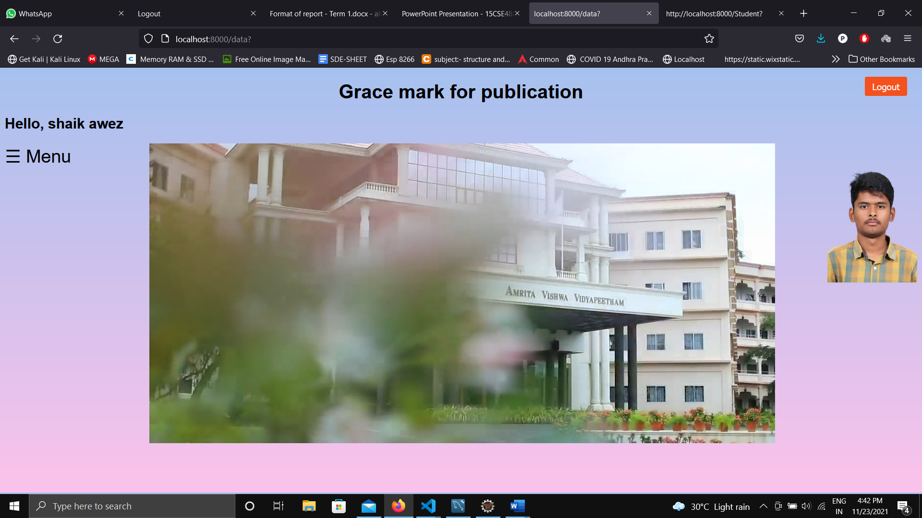

**Menu:**

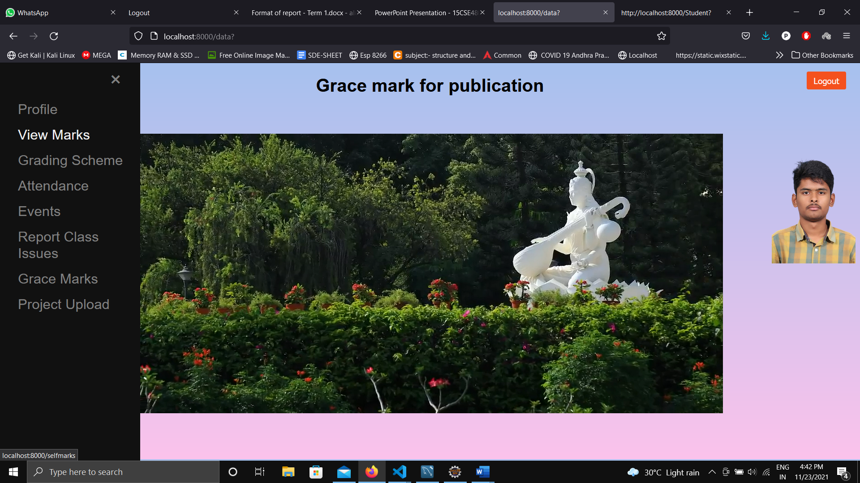

**Doc Uploading:**

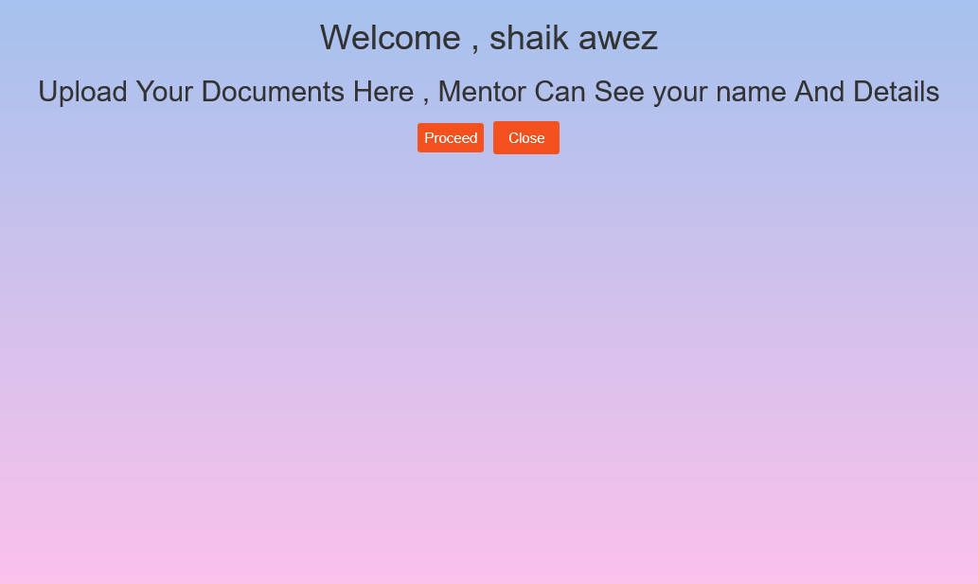

**Active logins:**

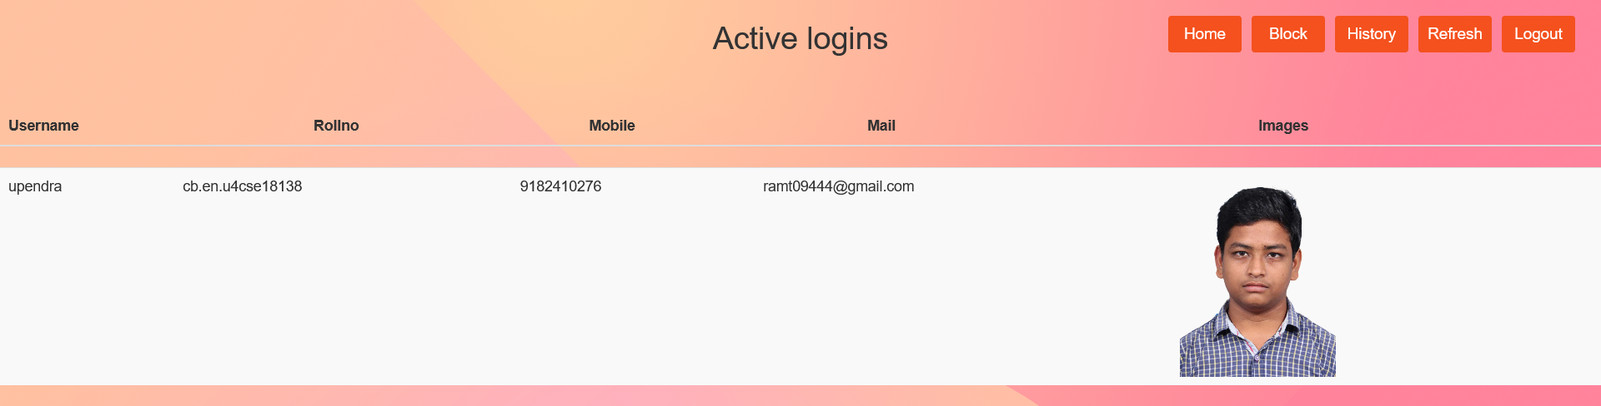

**User Block**

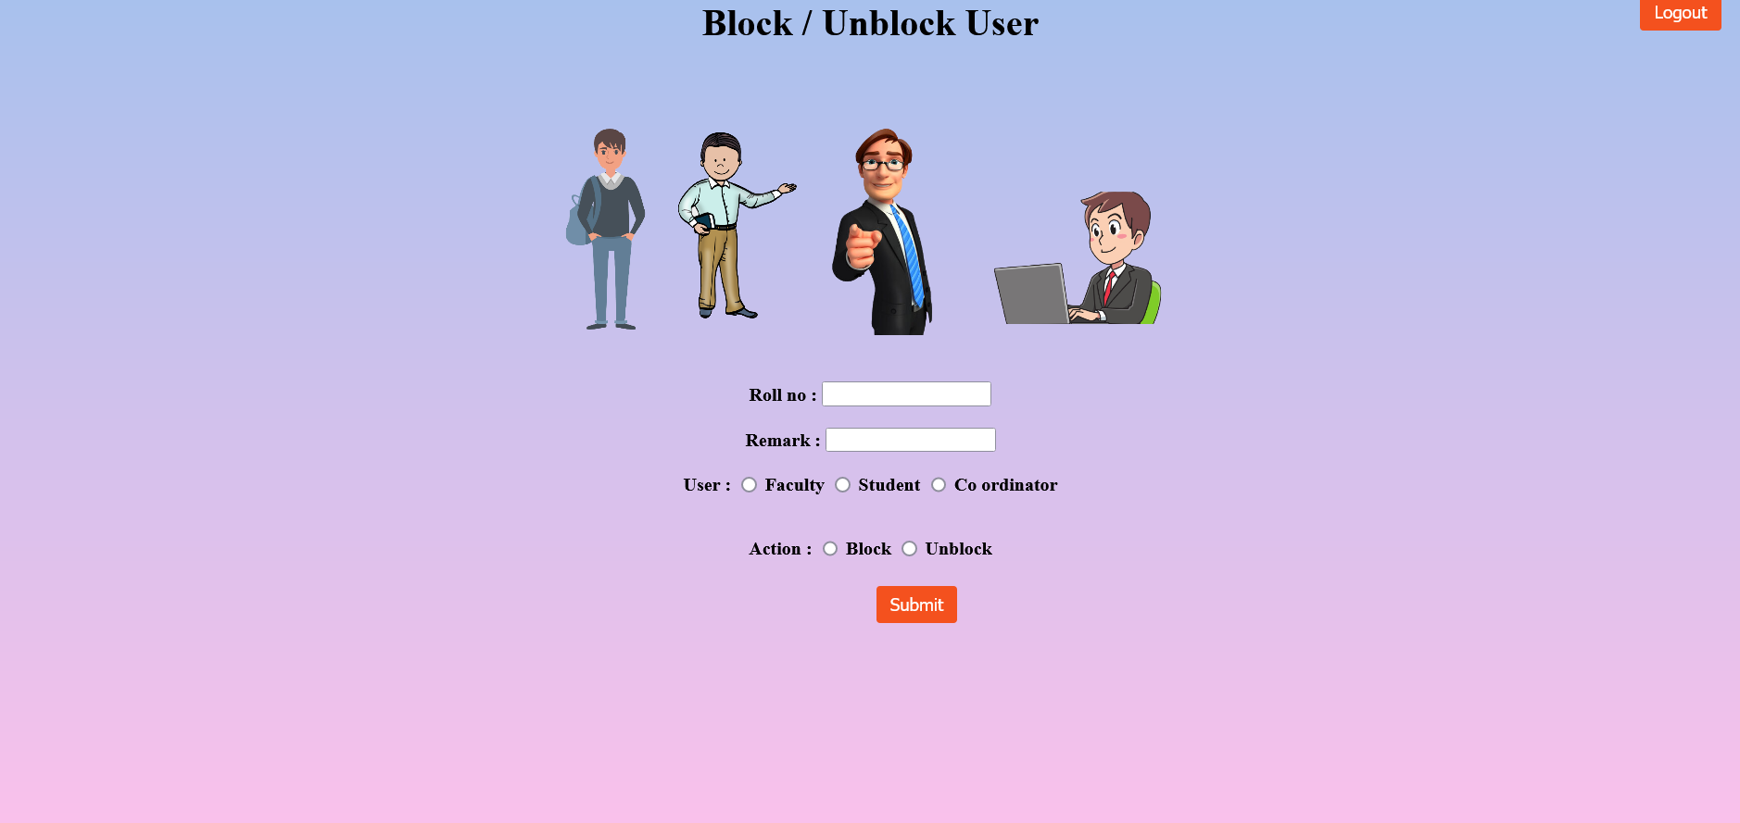

**Login History:**

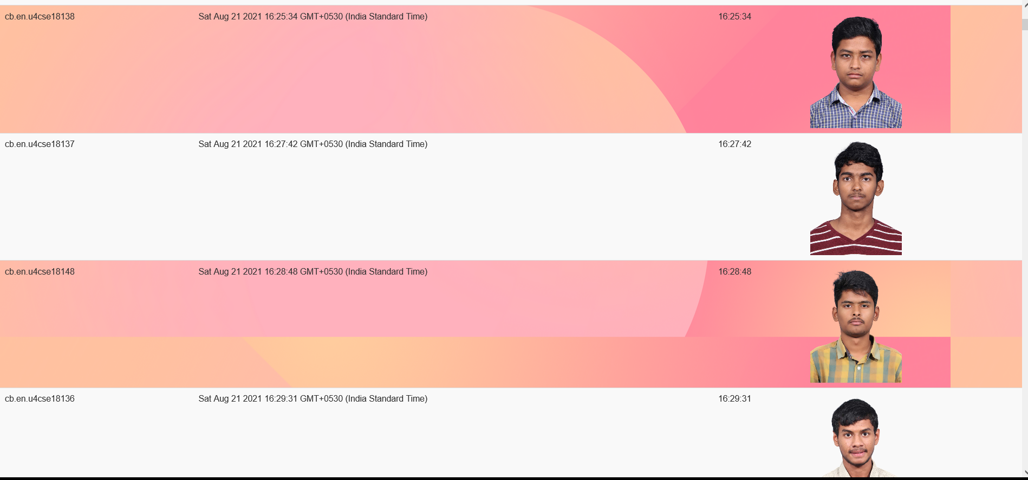

**Students Data:**

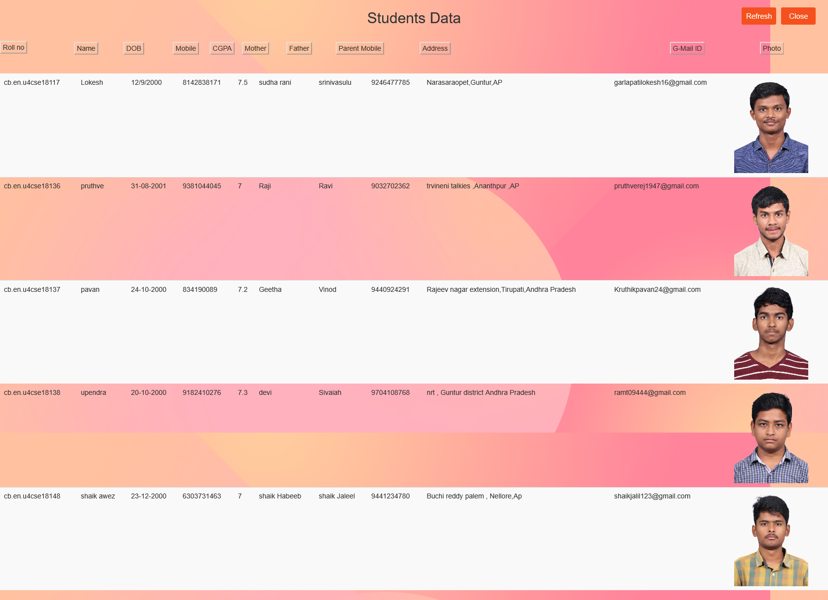**Project tracking :**

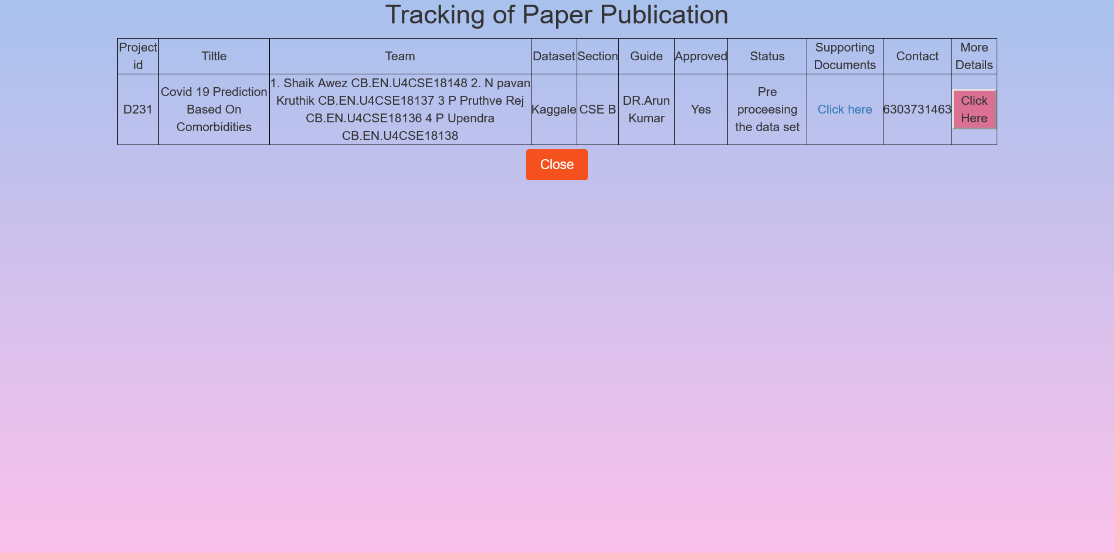

**More details on Project :**

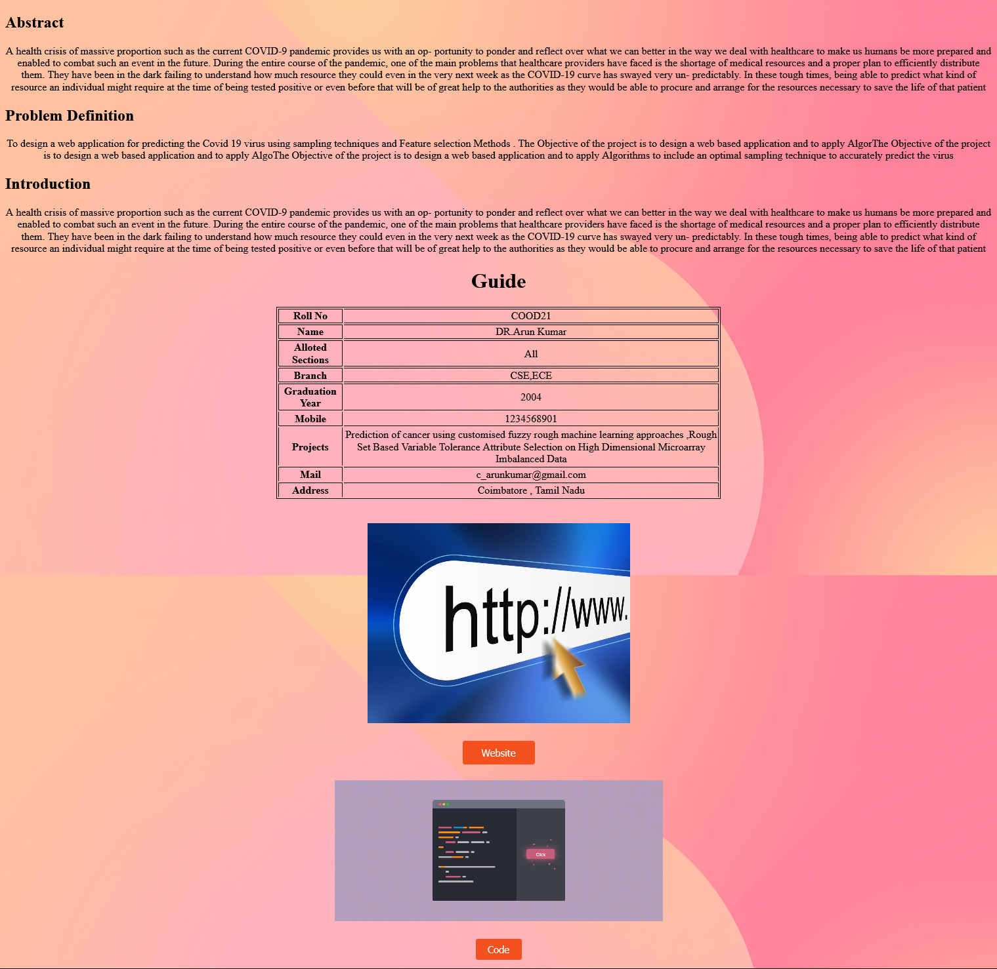

**Faculty Welcome page:**

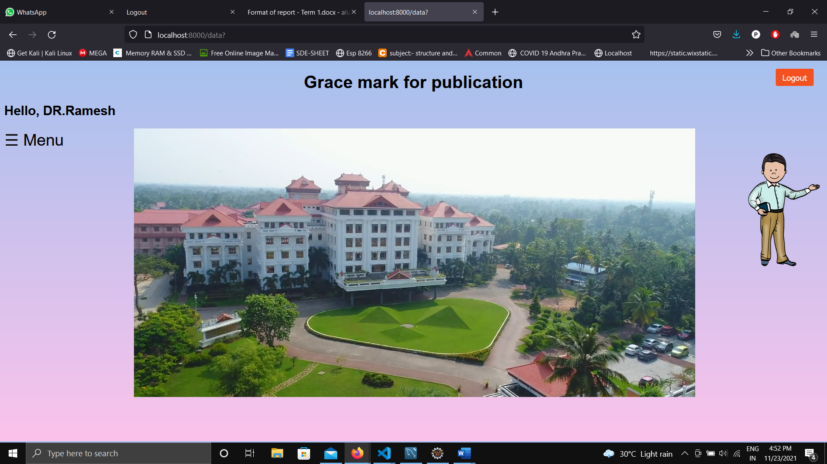**Menu :**

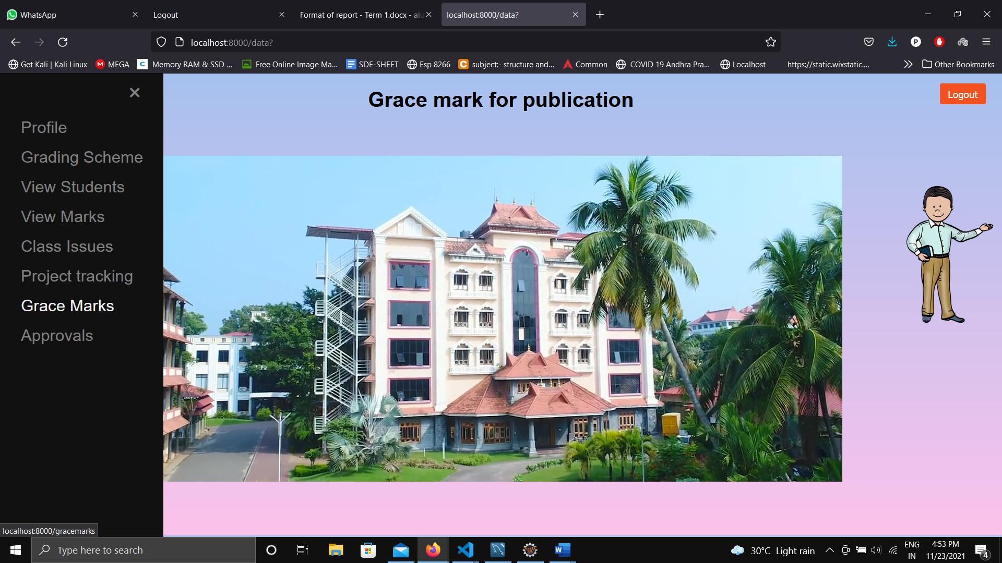

**Validation**

|  |  |  |  |  |
| --- | --- | --- | --- | --- |
| **S.No** | **Field** | **INPUT** | **SUCCESS**  **OR**  **FAILURE** | **REASON** |
| 1 | Password &Confirm Password | CB.EN.U4CSE18148  Awez123 | SUCCESS | Giving correct username and password |
| 2 | Password &Confirm Password | CB.EN.U4CSE18148  Awez1234 | Failure | Giving correct username and wrong password |
| 3 | Password &Confirm Password | FAC1  FAC1# | SUCCESS | Giving correct username and password |
| 4 | Password &Confirm Password | FAC1  FAC13# | Failure | Giving correct username and wrong password |
| 5 | Password &Confirm Password | COOD21  COOD21# | SUCCESS | Giving correct username and password |
| 6 | Password &Confirm Password | COOD21  COOD212# | Failure | Giving correct username and wrong password |
| 7 | Verifying User blocked by admin | CB.EN.U4CSE18117  BLOCKED | SUCCESS | Giving Correct Roll Number. |
| 8 | Verifying Grace marks update by coordinator | CB.EN.U4CSE18117  Plantation  10 | SUCCESS | Giving Correct Roll Number and Event. |

**Evaluation sheet:**

|  |  |  |  |  |
| --- | --- | --- | --- | --- |
| Roll No | Technology | Max Marks | Marks Awarded | Total (30) |
| 18117 | Business Logic  Integration | 10  10 |  |  |
| 18136 | Business Logic  Integration | 10  10 |  |  |
| 18137 | Business Logic  Integration | 10  10 |  |  |
| 18138 | Business Logic  Integration | 10  10 |  |  |
| 18148 | Business Logic  Integration | 10  10 |  |  |
|  | Project Documentation | 10 |  |  |